ABE 55700

Fall 2018

Group 1

Phase 7

Kathryn Atherton

Rohit Chatterjee

Barbara McAnulty

Hannah O’Neill

# Table of Contents

**Executive Summary** **8**

Phase 1 8

Phase 2 8

Pasteurization 8

Concentration 9

Fermentation 10

Drying 10

Phases 3 & 4 11

Pasteurization 11

Concentration 12

Fermentation 12

Spray Drying 12

Phase 5 12

Sterilization 12

Concentration 13

Fermentation 13

Spray Drying 13

**Abstract** **15**

**Introduction** **16**

Discussion: Yogurt Trends & Global Impact 16

History and Basics 16

Sustainable Processing 16

Global, Ethical, and Societal Issues 17

**Project Objectives** **17**

Understand the process of creating yogurt and alternative methods for creation 17

Create a recipe for yogurt and perform a mass balance on this recipe 17

Perform an energy balance on the recipe 17

Perform kitchen experiments to make a prototype of the yogurt 18

Communicate the results of the project 18

**Literature Review** **18**

Sterilization 18

Introduction to Pasteurization 18

Basis Behind Pasteurization 18

Heat Treatment 19

Alternatives to Heat Treatment 20

Sensory Characteristics of Pasteurized Milk Products 21

Discussion of Heat Treatment 21

Conclusion 22

Separation 22

Introduction 22

Current Methods of Concentration 23

The Ultrafiltration Method 23

Innovations in the Concentration Process 24

Processing Conditions 25

Yogurt Milk Composition 25

pH & Temperature 26

Hydrocolloid Stabilizers 27

Conclusion 27

Fermentation 28

Abstract 28

Introduction 28

Microbiology 28

Types of Lactic-Acid Bacteria 28

Figure 1: pH profiles with incubation temperature during the fermentation process of yogurt made from optimally heat treated, whey powder fortified skim milk, after inoculation with (a) a typical starter culture for stirred type yogurt, (b) a Bifidus starter culture and (c) a ropy strain starter culture. Brabandere and Baerdemaeker (1999). 29

Figure 2: Acid Production by L. bulgaricus (NYL1), Str. thermophilus (BYS2) and their combination. Bautistia et. al (1966). 30

Figure 3: Fermentation of Lactic-Acid Bacteria Varying Temperature. Ostlie et. al (2005). 31

Products 31

Figure 4: Lactic Acid Production during Yogurt Fermentation Varying Temperature and Bacteria. Ostlie et. al (2005). 32

Initial State of Culture 32

Additives 33

Equipment 33

Batch Process 33

Continuous Process 33

Monitoring pH 34

Conclusion 34

Spray Drying 35

Goals of Spray Drying 35

Methods 35

Equation 1 35

Equation 2 35

Process Inputs and Outputs 36

Effect of Spray Drying on Product 36

Alternative Drying Methods 37

Freeze-Drying 37

Microwave Vacuum Drying 37

Refractance Window Drying 37

Conclusions 37

Recipe and Ingredients 38

Product Ingredients / Functionality 38

Table 1: Ingredient Functionality 38

Product Recipe and Steps 38

Milk Fortification and Preparation 38

Fermentation 38

Supplementation and Dehydration 38

**Mass and Energy Balance Details** **39**

Overall Plant Mass Balance (for one hour) 39

Gantt Chart 39

Figure 5: Gantt Chart for one particle of milk throughout the yogurt-making process. 39

Processing Steps with Mass Balances 39

Sterilization 39

Regenerative Heating 39

Methods 39

Mass Balance 39

Pasteurization 39

Methods 39

Mass Balance 40

Concentration 40

Methods 40

Mass Balance 40

Further Breakdown into Mixture Components 40

Fermentation 40

Method 40

Mass Balance 41

Drying 41

Method 41

Mass Balance 41

Further Breakdown into Mixture Components 41

Processing Steps with Energy Balances 42

Sterilization 42

Regenerative Heating Energy Balance 42

Pasteurization Energy Balance: 42

Concentration 42

Energy Balance 42

Fermentation 42

Energy balance for countercurrent cooling to 40C 42

Super Pro energy balance for countercurrent cooling to 40oC 42

Energy Balance for filling and fermenting tank for 6 hours 43

Energy Balance for emptying tank for 6 hours: 43

Energy balance for countercurrent cooling to 15C 43

Super Pro energy balance for countercurrent cooling to 15oC 43

Drying 43

Energy Balance 43

Energy Balance on Air 43

Energy Balance on Yogurt 44

**Plackett-Burman DOE** **44**

Figure 6: Plackett-Burman DOE. Sixteen variables and three dummy variables were used over twenty runs. 44

Table 2: Plackett-Burman DOE Minimum and Maximum Values for Each Variable 44

**Unit Operations Design and Performance Curves** **45**

**Lab-Scale Experimentation** **45**

Sterilization 45

Figure 7: Pasteurization instrumentation showing toaster oven and beaker with skim milk 46

Figure 8: Thermal data for skim milk during pasteurization procedure 46

Concentration 46

Figure 9: Microfiltration system for lab scale experimentation 47

Fermentation 47

Figure 10: Initial pH Gradient for Lab-Scale Yogurt Fermentation 48

Figure 11: Yogurt Fermentation Image in Yogurt Maker 48

Figure 12: Beaker pH Profiles over Time 49

Figure 13: Beaker Temperature Profiles over Time 49

Drying 49

Figure 14: The constant temperature oven used for preliminary drying experimentation. The oven was set to 100oC and the yogurt was dried for thirty minutes 50

Figure 15: Results of drying experiment, moisture content [%] versus time [minutes]. After drying in the oven for thirty minutes, the yogurt lost enough water to reach the desired moisture content. 51

Figure 16: The yogurt before drying (left) and after drying for thirty minutes (right). 51

**Design Equations and Performance Curves** **51**

Table 3: Primary variables for pasteurization set-up 52

Figure 17: Heat transfer coefficient relationship between mass flow rate and exit stream temperature 52

Concentration 52

Figure 18: Hypothetical changing transmembrane pressure over time in microfiltration systems of varied pore size 53

Fermentation 53

Performance Curve 53

Figure 19: Effect of Temperature on Lactic Acid Fermentation over Time 54

Design Equations 54

Spray Drying 54

Equipment Design 54

Theoretical Performance Curve 54

Figure 20: Spray dryer performance curve of moisture content versus residence time at different air velocities. The theoretical data shows that the product dries faster at a higher air velocity, which is ideal for the process to prevent overheating the product and killing the microbes. 55

**Conclusions and Future Directions** **55**

**Appendix A: Data & Calculations** **56**

Sterilization 56

Regenerative Heating Energy Balance Equation 56

Pasteurization Energy Balance 56

Holding Tube Length 56

Heat Exchanger Power 57

First Heat Exchanger 57

Second Heat Exchanger 57

Fermentation 57

Table 4: Lab-Scale Yogurt Fermentation Raw Data 57

Drying 58

Energy Balance on Air 58

Energy Balance on Yogurt 58

Choi Okos Equation 58

**Appendix B: Super Pro Analysis** **59**

**Appendix C: References** **64**

# Executive Summary

## Phase 1

Group 1 chose dehydrated high-protein yogurt for a design project. Objectives for the project were agreed upon, including determining the process used for this project and alternative methods, performing mass and energy balances on the recipe, piloting kitchen experiments to make the product, and communicating the results of the project. Background information about yogurt, including its history, sustainability, and issues surrounding the process, were considered. Yogurt is popular with consumers due to its health benefits and variety of flavors; however, the production of a cup of yogurt requires 88 gallons of water, a quantity which is not necessarily ideal in terms of sustainable processing. Ethical questions with regards to the treatment of cows in the dairy industry have also been raised, causing 39% of consumers in the United States to incorporate more plant-based foods into their diets.

The basics of yogurt production was investigated. Four unit operations were selected based upon the desired process: pasteurization, concentration, fermentation, and spray drying. The concentration and spray-drying steps were selected because market research found that interes in spoonable yogurt decreased nearly 7% from 2015 to 2017 while more convenient and portable yogurt products are expected to see a 58% growth over the next four years. In addition, consumers have become more health-conscious and desire high-protein and low-sugar content in their yogurt. The concentration step will help concentrate the protein and dilute the sugar content while the spray drying step will make a more portable product.

## Phase 2

Each member of Group 1 chose a unit operation and discussed key themes for each. Based on the discussion, a final method for the unit operation would be implemented into future mass and energy balances. The four unit operations are pasteurization, concentration, fermentation, and drying.

### Pasteurization

Milk is a medium perfect for the growth of microorganisms, and in the past raw milk has been responsible for numerous food-borne diseases and illnesses. The heat treatment of milk, termed pasteurization, was capable of eliminating pathogens and enzymes that spoil milk to prevent widespread disease. Pasteurization is a common industrial process that generally uses heat treatment, but alternatives methods are being studied including hydrostatic pressure processing (HPP), UV light, and pulsed electric fields (PEF). Each of these methods have a different impact on the sensory and nutritional characteristics of the final product.

Heat treatment has three main options for processing. The first is vat pasteurization which is a batch process. It has also been termed low temperature long time (LTLT). The milk is held at 65 ℃ for 30 minutes to inactivate key pathogens. This process is commonly used in the yogurt industry because the raw milk is pasteurized in a large tank. Afterwards, the bacterial organism to begin fermentation is added to begin the process. Group 1 decided to do a concentration step to increase the amount of protein prior to fermentation, so it is more beneficial to use a continuous process such as high temperature short time (HTST). HTST keeps the milk at 72 ℃ for 15 seconds to reach the thermal death time for the pathogens. A plate heat exchanger is used to ensure high heat transfer rates and a holding tube keeps the milk at the desired temperature for a set time. The velocity profile is not uniform inside the tube, so the time is calculated based on pasteurizing the fastest particle of milk - through the center. Higher temperatures with the varying times had been tested to see if HTST method could be improved. The microbial reduction was not significant and there were negative impacts to sensory characteristics of the milk such as giving a burnt flavor, so 72 ℃ for 15 seconds is still the industry standard. Ultra pasteurization is another continuous method that places the milk at extremely high temperatures for a short time. The standard method is to heat milk to at least 138 ℃ for two seconds to achieve the desired thermal death time. UP places a larger thermal load on the product than HTST giving UP milk a distinct cooked flavor.

Alternative methods to pasteurize milk were discussed such as HPP, UV light, and PEF. HPP has been used more commonly in industry with fruit, vegetable, meat, and seafood products. It uses an elevated pressure of 100 - 1000 MPa. Unlike heat which takes time to have all of the product at a uniform temperature, pressure is applied to the entire volume, so the time for HPP processing is independent of sample size. This is an extremely attractive aspect of HPP. There are negative impacts of HPP when compared to HTST such as the denaturation of native proteins like whey and disturbed structure of casein. UV light can also be used to pasteurized milk by using an electrodeless lamp apparatus that allows milk to flow through a helical quartz tube with a certain frequency. UV light has shown some variability due to differences in bacteria and their possible resistance to UV irradiation, showing clear limitations. PEF has been used to inactivate pathogens in milk processing by using a pulsed electric field which applies potential difference across the cytoplasmic membrane. It provides a low processing temperature and low energy usage. PEF has obstacles with large volumes because high power pulses are more expensive and unstable. Bubbles are also an issue in the volumes because air is not conductive and high voltages across it could cause discharges and minor explosions, damaging the product.

After studying literature into the possible methods for milk pasteurization, HTST was chosen to be used in the production of dehydrated greek yogurt. It is a continuous process which is the desired method based on the arrangement of the unit operations and it retains the key sensory and nutritional characteristics. Alternatives to heat treatment are still in the early side of testing and have not been studied to the extent that heat treatment has. In the future those methods may be evaluated with more information.

### Concentration

Concentration during yogurt production removes water, low-weight proteins, and salts to produce a thicker, creamier final product with a distinct flavor. Protein fractionation during this process retains casein and removes whey from the yogurt, which creates a higher concentration of protein in the final product. Filtration is a common concentration method used within the dairy industry, and reverse osmosis may be used in conjunction with this technique to remove additional water from the product stream. Another alternative concentration method is centrifugation, which separates a batch based on weight.

Filtration processes in industry operate using a cross-flow or dead-end method. The cross-flow method runs a feed stream tangentially along a membrane, and the smaller particles filter through the membrane into a permeate stream. The retentate continues along the original path and exits at the other end. Alternatively, the stream in a dead-end filtration runs directly towards a membrane. Permeate filters through, while the retentate remains trapped in the original location and forms a significant cake layer along the membrane. Group 1 chose a cross-flow filtration method, as the retentate stream would be utilized in the subsequent fermentation process. During this process, membranes of various sizes can be used depending on the particle removal goal of the separation process. Micro-, nano-, and ultra- filtration utilize membranes of decreasing pore size, which allow less and less through the membrane. Ultrafiltration is commonly used in dairy concentration processes, however, this pore size would not allow the passage of whey protein through the membrane. The goal of Group 1’s concentration step during yogurt production was the removal of whey protein from the yogurt product, meaning a larger pore size that retained casein protein while passing whey protein was required. A microfiltration system with a 0.1 uM membrane pore size was chosen to meet these requirements.

Depending on the filtration design, multiple passes over a filter may be made to increase the concentration factor of the process, and a reverse osmosis step may also be added to remove additional water from the final stream. Group 1 chose to maintain a concentration factor of 2 and use a single-pass microfiltration system that removes ~68% of the whey protein and water from the milk stream. This is because lactose is removed by the microfiltration process and exits through the permeate stream. Lactose is required for the subsequent fermentation step of yogurt production, meaning some of this product must be maintained in the exit stream of the concentration process. A single-pass system allows significant removal of water and whey protein while maintaining some of the lactose required for fermentation. Within the greek yogurt industry, the concentration process often occurs after fermentation and this problem is avoided. However, the permeate waste stream of post-fermentation concentration contains an acid whey byproduct that is harmful to the environment and difficult to dispose of properly. Concentrating the milk stream prior to fermentation avoids this issue, as the whey byproduct is a non-harmful sweet whey variant. After studying all variations of the concentration process, a continuous, cross-flow microfiltration process with a 0.1uM membrane pore size was chosen for the milk concentration step of Group 1’s design.

### Fermentation

For batch yogurt fermentation processes, *Lactobacillus bulgaricus* and *Streptococcus thermophilus* comprise the typical starter culture; however, literature evaluating several other probiotic bacteria is available. Each strain has optimal conditions, such as temperature, to which the fermentation process should be adjusted. In addition to varying the species and strains of traditional free culture bacteria, academic research is evaluating the additions of encapsulated probiotics, mainly to enhance the nutritional value of yogurt.

Fermentation broth is traditionally a mixture of milk and lactic-acid bacteria, which reduce the pH causing coagulation of proteins. While many fermentation broths include extra powdered milk proteins, recent publications have evaluated the additions of non-traditional food products, such as herbs, to yogurt fermentation for nutritional benefits as well as increased efficiency of yogurt fermentation. Further yogurt fermentation research should expand upon the nearly endless combinations of lactic-acid bacteria strains with various pre-treated milks.

While yogurt fermentation is typically a batch process, continuous processing has been successful but with significant drawbacks. Combining novel methods of increasing efficiency of fermentation can be combined with the exploration of a continuous or semi-continuous yogurt fermentation process.

### Drying

Spray drying is a principle method of drying in the dairy industry which converts a product form a liquid to a powder, removing moisture from the product by atomizing it and exposing it to a chamber of hot air. It is beneficial because it increases the shelf-life of the product without a refrigeration requirement and decrease the cost of shipping. The process also produces minimal damage to the product microstructure and any living organisms as the product never reaches a very high temperature.

There are three steps of spray drying: atomization of the product, drying in hot air, and separation of the dry particles from the air. The process inputs are the wet yogurt and hot dry air and the outputs are the dry particles and humid air. Lower temperatures for the hot air input are ideal for the final product consistencies, however, the residence time in the dryer increases as the temperature decreases. The spray drying process doubles the shelf-life of yogurt and decreases the number of microorganisms in the final product. Acetaldehyde and diacetyl, two flavor components of yogurt, degrade during the drying process, but adding whey concentrate improves the taste of the final yogurt.

Alternative methods of drying were investigated, including freeze-drying, microwave vacuum drying, and refractance window drying. Freeze-drying is the most ideal of the methods, as it best retains the microorganisms and taste of the yogurt; however, it is the most expensive method of drying. As such, the traditional spray-drying method was chosen for this project.

## Phases 3 & 4

Group 1 used SuperPro to create a plant process flow diagram for the production of dehydrated greek yogurt. An overall plant mass balance was done and each unit operation discussed in phase 2 was analyzed with a mass and energy balances for each unit operation based on a standardized recipe for each step. The calculations gave key parameters necessary for each processing step. The mass and energy balances were done on pasteurization, concentration, fermentation, and spray drying. The equations were based on a high 500 kg/hour input of raw milk resulting in 40 kg/hour output of dehydrated greek yogurt in a powder form.

### Pasteurization

A regenerative process is used where the heat treated milk is used to preheat the raw milk input, and the raw milk is used to cool down the pasteurized milk. In this way, the heat can be recycled saving in energy costs. A positive displacement pump is also placed after the plate heat exchanger so that there is higher pressure on the product stream, so if there is a leak, the product will leak into the raw stream. The sterilized milk is also cooled, so that proteins are not denatured. The milk is heat treated to remove harmful pathogens and removal of microorganisms that can spoil the taste and shorten the shelf life of milk products. High temperature short time (HTST) pasteurization is used in a plate heat exchanger to heat the milk to 80 ℃. This is a continuous process that heats up the milk rapidly and keeps it in a holding tube for a residence time of at least 15 seconds to effectively destroy the pathogens. Two heat exchangers are used. One heats the raw milk with the pasteurized milk and the second heats up the preheated milk with steam. The temperature of the outcoming stream in the first heat exchanger is 50 ℃ and in the second it is 80 ℃. The processing time is set to one minute, but mostly depends on the desired residence time. For the recipe, group 1 set the residence time to be 20 seconds to process 500 kg milk/hour. After doing the energy balance the outgoing preheat milk was found to be 34 ℃. The area of the first heat exchanger is 0.00315 m2 by assuming a heat transfer coefficient of 267 W/m2K which was found in Geankoplis for a plate heat exchanger. A mass flow rate of steam to heat the incoming preheat milk to 80 ℃ in 1 minute was 39.3 kg/s to heat. The area of the second heat exchanger was 1.85 m2.

### Concentration

The concentration process inputs the sterilized milk stream and separates components based on molecular weight. 68% of whey protein, lactose, and water pass through the membrane and enter a permeate stream, while casein, fat, ash, and 32% of permeable components remain in the exiting concentrated stream. 500 kg of sterilized milk enter the system, and 277.6 kg of concentrated milk exit in the product stream. The microfiltration operation occurs at a temperature of 50° C and an average transmembrane pressure of 0.5 bar (50 kPa) over a 90 minute period. With a total membrane area of 100m2 and pipe heights of 2.5 m, a shaft work requirement of 30,000 kJ was found for the process. A centrifugal pump will be used for the concentration process of the yogurt production.

### Fermentation

Prior to fermentation, the 277.6 kg per hour of concentrated milk is cooled from 50 C to 40 C in a countercurrent double-pipe heat exchanger. After 6 hours of filling, 1665.6 kg of milk is in the fermenter. To restore the milk to its original lactose concentration, 48 kg of lactose is added followed by the starter culture. Assuming no mass is lost, all fermented yogurt is cooled to 15 C before being spray dried. The cooling water used in the heat exchangers is utilized in the fermenter water jackets. Energy balances determine parameters associated with the heat exchangers such as mass flow rate and area.

### Spray Drying

Assuming no loss of mass from the fermentation step and that the final product has a moisture content of 6%, a mass balance calculation determined that 236.19 kg per hour of water should be removed from the yogurt to create the final dehydrated product. Psychrometrics were used to determine that 1505.35 kg of air per hour is required to perform this dehydration. This produces 48.13 kg of dry product per hour. An energy balance was performed given the temperatures of the input yogurt, input hot air, and output humid air from literature to find the temperature of the yogurt leaving the process to be 40 oC.

## Phase 5

Group 1 created a Plackett-Burman DOE of sixteen variables that could be changed within the production process, three dummy variables to account for randomness, and twenty runs. The minimum and maximum values for each variable were determined. One run of the process was performed and results were recorded, as described below. Design equations and performance curves were also found in literature and used to draw conclusions about the future design of experiments.

### Sterilization

Lab-scale pasteurization equipment used a toaster oven to heat up the milk. The equipment provided only allowed batch processing. Due to the difficulty of obtaining raw skim milk, skim milk was purchased and 300 mL of was poured into a beaker and it was heated to 65 oC for 35 minutes. The microbial reduction was going to be evaluated by spreading a sample on an LB agar plate before and after the batch pasteurization processing, but there were no LB agar plates present. While heating the milk, the toaster oven did not have very accurate temperature control. A thermometer was used every 10 minutes to check the ambient temperature inside the toaster oven and the temperature of the milk. The opening and closing of the toaster oven would have an impact on the heat transfer. Power measurements were taken of the toaster while it was operating, so the total power consumption was found to be 2912 kJ. The processed skim milk was meant to be evaluated based on odor, consistency, and taste. Due to food consumption restrictions in lab, the milk was not tasted, but in the future this will be a key parameter to evaluate the pasteurization process. The odor of the milk smelled a bit more sour than the purchased skim milk, but the consistency was equivalent between the two.

For future experiments, hopefully equipment designed for the pasteurization process can be used. The designed pasteurization system is a continuous process that uses a plate heat exchanger to heat up the milk and it is held in the holding tube. The area of the heat exchanger and the length of the holding tube are key design parameters. The areas for the two heat exchangers were calculated and mentioned earlier to be 0.00315 m2 to heat the raw milk and 1.85 m2 to heat the preheated milk to sterilization conditions. These two heat exchangers consume 256.3 kW and 1710.3 kW, respectively. Afterwards the milk would be held in the holding tube for 20 seconds to reach thermal death time. The length of the holding tube is 1.66 meters. The performance of the heat exchanger depends on the exit temperature of the milk as well as the mass flow rate of the heating fluid. With an increase in flow rate there is an increase in the heat transfer coefficient inside the heat exchanger. These design parameters were considered when choosing the parameter values for the pasteurization processing.

### Concentration

The ultrafiltration equipment within the lab required for concentration testing was not operational during initial testing. When working, the ultrafiltration system will be used to simulate membrane filtration of pasteurized milk. A single-pass filtration method will be used, and the energy requirements, run time, and transmembrane pressure of the system will be observed. An ultrafiltration system operates at a higher transmembrane pressure than a microfiltration system, but this can still be used as an approximation. Following filtration, the protein concentrations of the incoming and outgoing streams will be compared to determine the quality of the filtration. The overall protein content of each stream can be tracked using the Kjeldahl method, however, this metric will not account for fractionation of protein within each stream. An additional spectrophotometry test such as an SDS-page gel can be included to compare relative amounts of the individual protein species within each stream.

### Fermentation

Lab-scale fermentation equipment included a home yogurt maker with six beakers. Dannon yogurt provided the starter culture in skim milk. Varying extent of reaction measured by pH, the six beakers were concocted such that the lab-scale fermentation could collect data on the entire yogurt fermentation process in a shorter amount of time than a start-to-finish fermentation of upwards of 6 hours. In each beaker, variables that changed as a result of the pH gradient were lactose concentration and starter culture concentration; however, those variables do change in approximately the same way during a start-to-finish fermentation process. Both temperature and pH data were collected every 20 minutes on all six beakers. Because lab-scale double-pipe heat exchangers are not available, the materials were not heated and cooled to the recipe temperatures before and after fermentation. Each beaker had a varying heat capacity and rate of heating, which impact the fermentation performance.

### Spray Drying

The spray drying equipment was unavailable for usage, so a constant temperature oven was used. It was set to 100oC and the yogurt was weighed and spread onto a baking sheet in a thin layer and heated in the oven for thirty minutes. It was removed and re-weighed at five-minute intervals. Using the USDA database to find the original moisture content of Greek yogurt, the change in moisture content was calculated at each time interval. After thirty minutes, the yogurt, which started with 83% water content, reached the desired moisture content of 6%.

For future iterations of the drying experimentation, a dryer with a volume of at least 204.73 m3 should be used. This was determined with the mass of air used to dry per hour and assuming a residence time of each particle being about ten seconds. Performance curves from literature show that as time in the spray dryer increases the moisture content of the final product decreases. This relationship varies with the air velocity of the hot air in the dryer, with faster air decreasing the moisture content of the final product more quickly. As such, a high air velocity should be used to decrease the residence time in the dryer and prevent overheating of the product, killing microbes and degrading important molecules for the product’s taste.

Phase 7

Considering literature reporting the operation of all four unit operations, a reasonable and responsible dried yogurt process has been designed. Preliminary lab tests resulted in data to guide future piloting efforts. Group 1 has gathered vital information to proceed in tweak the process for maximum efficiency. Sensory analyses and further market analysis will guide the scaling of the powder production.

# Abstract

Yogurt has been a popular food for a variety of cultures for hundreds of years; however, recent industry trends have shown that the popularity of traditional spoonable yogurt has decreased while new, innovative forms of the food are becoming the new norm. In addition, most consumers value protein content in the yogurt products they buy. Because of these trends, a dehydrated, high-protein yogurt powder was identified as a novel product. To create this product, four unit operations were identified: pasteurization, concentration, fermentation, and spray drying.

Milk pasteurization occurs by HTST at 80℃ for 20 seconds. The process uses regenerative heating due to it energy efficiency. A positive displacement pump ensures if leaks occur, the sterilized stream enters the raw milk stream. Using 256.3 kW, the first heat exchanger preheats raw milk with sterilized milk, and the second heat exchanger heats preheated milk to pasteurization conditions over 1.85 m2 with 1710.3 kW. Cross-flow microfiltration system was used for the concentration process to remove water, salts, and whey protein. The microfiltration membrane pore size allows protein fractionation and retains casein protein in the product stream. The mass balance assumes a 68% removal of whey, water, and lactose from the incoming pasteurized milk stream, and a concentration factor of 2 produces 277.6 kg of product with a high casein content. The system operates at a transmembrane pressure of 0.5 bar, a height of 2.5 m for each pipe, and a total membrane area of 100m2. The 30,000 kJ of required energy for operation will be provided by a centrifugal pump maintaining fluid flow. The concentrated milk is cooled to 40oC, the optimal temperature for fermentation with *Lactobacillus bulgaricus* and *Streptococcus thermophilus*. After filling a ferenter for 6 hours, lactose powder is added to restore the milk to its original lactose concentration before adding the starter culture. After fermentation, the yogurt is cooled to 15oC. Spray drying was the method chosen for drying because it is cost-efficient and the standard method for the dairy industry. The yogurt enters this step at a temperature of 15oC along with hot air at a temperature of 171oC. Within the equipment, the air drops in pressure by 98 kPa and exits as humid air at a temperature of 60.5oC while the yogurt leaves as a powder. The mass balance allowed for the identification of the amount of water to be removed from the fermented product and the amount of air required to do so and the energy balance found the final temperature of the dried yogurt product. A 204.3 m3 spray dryer will be used to perform this step such that 1505.35 kg of dry, hot air can flow through the equipment each hour and produce 48.13 kg of dried yogurt per hour.

For lab-scale experimentation, the equipment provided allowed only batch processing. For pasteurization, the milk was held above 65 ℃ for 35 minutes. Sensory characteristics of the milk were evaluated. Concentration equipment was unavailable, but the Kjeldahl method will be used to monitor the overall change in protein concentration while an SDS-PAGE will compare relative amounts of each individual protein. Fermentation was tested by monitoring the pH of yogurt at six extents of reaction. The pH and temperature were measured every twenty minutes. Spray drying equipment was unavailable, but a 100oC oven was used to model the process. Spread thinly on a baking sheet, yogurt was massed periodically. The initial moisture content was 83%. After drying for 30 minutes, the final moisture content was 6%, which is the desired moisture content for the product.

# Introduction

## Discussion: Yogurt Trends & Global Impact

### History and Basics

To cover the full scope of yogurt processing information, milk production must be considered. Approximately 20% of the world’s milk is produced in the United States. At an efficiency of 8.50 t/cow, the United States is the second most efficient milk producer. Great strides have been made towards the packaging and processing of milk products to increase yield production. Over the course of the early 2000s, manufacturing developments reduced the number of plants by 45% and increased the production yield by 4-5%. Continued developments in the milk industry increase the production of fermented dairy products such as yogurt (Chandan, 2006).

Yogurt is a fermented milk product and is thought to be discovered by primitive methods of storage in warm climates. With a host of lactic acid bacteria such as *Lactobacillus bulgaricus* and *Streptococcus thermophilus*, milk sours the at the appropriate growth temperatures which adds flavor and texture to the fermented product. There are 400 diverse products created by milk fermentation adding different flavors while conserving vital nutrients of milk. The fermentation of yogurt relates to process parameters such as moisture content and protein level. The majority of yogurt utilizes cow’s milk as a starting material and mixing with nonfat dry milk, milk protein concentrate, or condensed skim milk to produce a custard like consistency. There are multiple varieties of yogurt to investigate such as plain, fruit flavors, whipped, dried, and frozen (Chandan, 2006).

The popularity of yogurt soared based on consumer perceptions of health benefits. It is a significant source of protein and calcium and there is evidence it may lower the risk of diseases type II diabetes, obesity, and irritable bowel syndrome (“Yogurt”, 2018). Due to the possible health benefits and distinct flavor, the yogurt market reached a retail sales of $8.8 billion in 2017 (“United States”, 2018). Novel developments are being investigated to see possible market impacts.

### Sustainable Processing

The World Wildlife Foundation claims that the greenhouse gas emissions created by cows and their manure are contributing to climate change while unsustainable dairy farming practices can lead to the loss of prairies, wetlands, and forests. Vast quantities of water are also used to keep cows productive and profitable; according to the Water Education Foundation, it takes 88 gallons to produce a cup of yogurt and up to 616 gallons of water to produce a 4-ounce hamburger.

Laureati et al. performed a social sciences study to assess consumer attitudes toward sustainable production and how those influence consumer preferences in yogurt. In general, consumers see “sustainability” as a positive ideal but do not necessarily adjust their buying behavior to align with their vision for a sustainable future. Some of this contradictory behavior is related to the inability of surveyed consumers to produce a consistent, informed definition of sustainability, which is a vast, interdisciplinary concept. Consumers with a more developed passion for sustainability had higher expectations for organic yogurt products. As a result, negative disconfirmation, when expectations for the product were higher than the assessment product characteristics after consumption, occurred only in consumers who were sustainability-minded or uncertain about sustainability. In order to maintain a customer base for those groups of consumers, organic products must meet or exceed expectations--an extra pressure that non-organic products do not have.

### Global, Ethical, and Societal Issues

As yogurt is a dairy product, it is subject to the ethical dilemmas of dairy industry. According to an article written by Chas Newkey-Burden for *The Guardian* (2017), in order to produce the milk used in dairy products, female cows are artificially inseminated and then her calf is taken away from her in as little as 36 hours after birth. The milk produced by the cow for the calf is what is harvested for sale. The mother is typically stressed, wondering where her child is. Male calves are raised to be sold as veal while female calves are prepared to become dairy cows as well. Dairy cows typically live to be five years old, when their natural lifespan can be up to 25 years (Newkey-Burden, 2017).

In addition to the stress of the cycle of impregnation and milk production, Newkey-Burden reports, dairy cows are often injected with hormones and antibiotics to ensure that they produce more milk than they naturally would; naturally, a cow will produce 2 liters of milk for her offspring, but some farmers will give a cow enough hormones to cause her to carry 20 liters of milk, making her udders heavy and exhausting her body. Once she is no longer profitable, she is sold to become beef (Newkey-Burden, 2017).

These ethical issues have caused many people to adopt vegetarian or vegan diets, cutting out meat and dairy products. According to a Nielsen survey quoted by the Food Revolution Network, 39% of consumers in the United States are trying to incorporate more plant-based foods in their diets.

Being a dairy product, the yogurt market is affected by dietary restrictions, such as lactose-intolerance or allergies. Scrimshaw and Murray found that in North America, 79% of Native Americans, 71% of blacks, 51% of hispanics, and 21% of caucasians had lactose maldigestion, which is clearly evolutionarily linked. Consumers with an inability to process lactose may elect to purchase medicine to help them digest the sugar or to purchase products that they can easily consume.

# Project Objectives

## Understand the process of creating yogurt and alternative methods for creation

* + Comprehend methods of dehydrating and rehydrating a food product
  + Recognize the physical and chemical changes performed during yogurt creation
  + Identify issues for the product including pathogens, spoilage, and fermentation cultures
  + Be aware of the effects of processing on the quality and functionality of the product and identify methods to reduce waste and energy consumption

## Create a recipe for yogurt and perform a mass balance on this recipe

* + Identify recipe including processing steps and ingredients
  + Perform component mass balance at each step and for the overall process
  + Identify the materials needed to conduct experiments

## Perform an energy balance on the recipe

* + Include thermal and physical properties in energy balance calculations
  + Record types of heat transfer mediums required

## Perform kitchen experiments to make a prototype of the yogurt

* + Develop Plackett-Burman experimental design
  + Examine variables of the final product to determine the success of the product
  + Present preliminary results
  + Suggest future improvements

## Communicate the results of the project

* + Create powerpoint presentation of process and results
  + Final literature review
  + Summarize process and results
  + Future improvements

# Literature Review

## Sterilization

### Introduction to Pasteurization

In the production of milk products many harmful microbes are capable of contamination in handling or processing steps. Raw milk has not been pasteurized to remove harmful bacteria and was responsible for 1,909 illnesses and 144 hospitalizations from 1993 through 2012 (Centers for Disease Control and Prevention, 2017). The pasteurization of milk is imperative for any process that employs milk products. In the analysis of yogurt production, pasteurization is a key unit operation. Pasteurization is the removal of pathogenic microorganisms. The method for removal can vary, but the most common is heat treatment over a period to remove the kill the pathogens. Heat treatment also provides an additional benefit of destroying substances and microorganisms that can spoil the taste and shorten the shelf life of milk products such as yogurt (Bylund, 1995). In terms of heat treatment there is vat pasteurization (LTLT), high temperature short time (HTST) pasteurization, higher heat shorter time (HHST), and ultra-pasteurized (UP). LTLT was the original method which heats milk in a large tank for at least 30 minutes. The primary use was geared towards preparing milk for starter cultures in processing yogurt, cheese, buttermilk, and ice cream mixtures in a batch format. HTST is the most common method of pasteurization in the U.S. and uses a plate heat exchanger to heat milk temperatures to at least 72 °C for at least 15 seconds and then rapid cooling in a continuous process. HHST uses different equipment and higher temperatures for a shorter time. UP heats milk to at least 138 °C for two seconds. (International Dairy Foods Association, n.d.). Alternatives to heat treatment include high hydrostatic pressure processing (HPP), UV light, and pulsed electric fields (PEF). These three methods are discussed in their potential for microbial reduction and extension of shelf-life. Possible limitations and benefits are discussed to compare the pasteurization methods against heat treatment. In the yogurt industry, heat treatment is considered ideal for the removal of microorganisms and removal of enzymes to prolong the shelf-life of yogurt. With the production of dehydrated Greek yogurt, a high amount of whey and casein protein is necessary. Thermal processing’s impact on the substances in yogurt is evaluated to see if they can possibly be modified to make the desired product.

### Basis Behind Pasteurization

Prior to heat treatment, milk was ripe with microorganisms capable of causing widespread disease such as tuberculosis and typhus. In the 19th century, Louis Pasteur studied the lethal effect of heat on microbes and its use to prolong shelf life coining the term pasteurization. The necessity of heat treatment was clear to everyone, but the methods for doing so were not uniform. Milk could be either underheated or overheated, allowing harmful bacteria to propagate disease or leaving milk with a cooked flavor. The discovery of a phosphatase enzyme present in raw milk that was removed by heat exposure over a period and the absence of this enzyme indicates sufficient heating. The targeted organism was *Mycobacterium tuberculosis* which was most resistant, so any heat treatment capable of destroying T.B. was sufficient in destroying other pathogens. Another benefit to heat treatment was the removal of enzymes that speed up the spoiling and shorten the shelf life of milk. There are still many options to accomplish sufficient heat treatment.

### Heat Treatment

The original heat treatment was a batch process where milk was heated to 63 °C for 30 minutes. A study used batch pasteurization with heat treatment at 65.5 °C for 30 minutes to remove *Mycobacterium paratuberculosis*, a pathogen responsible for Johne’s disease which affected 20-40% of dairy herds according to the National Animal health Monitoring System. After 28 weeks incubation post heat treatment the samples were relatively free of contamination.

Most milk processing happens through high temperature, short time (HTST) pasteurization. It is a continuous process where heat exchangers are used to heat and cool allowing microbes and enzymes to be deactivated in the holding tube. More specifically, a plate heat exchanger is used which allows for high heat transfer rates. Within the holding tube, the milk must have a sufficient resident time to allow for effective destruction of the harmful pathogens (Aguiar, 2014). HTST generally keeps milk at 72 °C for 15 seconds followed by a rapid cooling step. The heating step by a heat exchanger depends on product flow rate, physical properties of the liquid, temperature, pressure drops, heat exchanger design, cleanability requirements, and required running times. The product flow rate depends on capacity and higher flow rates require larger heat exchangers. The important physical properties in the heating of the liquid are density, specific heat, and viscosity. A countercurrent flow can be used within the heat exchanger to have the most efficient temperature difference between the liquid running through the heat exchanger (generally water) and the milk that is heated. As the heating process continues over time it eventually has deposits and must be cleaned. The size of the heat exchanger depends on the required holding time in the holding tube. The velocity profile is not uniform, so the time is calculated based on pasteurizing the fastest milk particle. (Bylund, 1995). A study was performed to evaluate the appropriate pasteurization temperature. Temperatures of 72, 75, 78, 80, 85, 90 °C were looked at over longer holding times of 15, 20, and 25 seconds. The presence of *Mycobacterium paratuberculosis* which causes Johne’s Disease in cattle, sheep, and goats was the desired pathogen to be deactivated. Results indicated that 72°C/15 seconds was only effective in removing the pathogen if it was initially present in less than 100 cfu/mL. The increased temperatures and times reduced the number of bacteria, but it was still in a detectable portion and it was concluded that higher temperatures and times could not assure the complete inactivation of the pathogen, so 72°C and 15 seconds is the ideal temperature to remove pathogens and retain nutrients (Grant, 1999).

Another continuous process for heat treatment is ultra-pasteurization. This method has shown advantages over batch pasteurization in energy savings, time savings, improved process control, and a longer shelf life for the product. The thermal effects of a continuous flow ultra pasteurization system of 149 °C for 3.3 seconds was compared to a batch system at 82 °C for 30 minutes. The chemical change of the product was evaluated based on a computer program. The results of the study showed that the ultra-pasteurization system had fewer chemical changes through the cooling step because there was less undesirable destruction of nutrients after there was sufficient destruction of pathogens (Labropolous, 1981).

### Alternatives to Heat Treatment

Alternatives to heat treatment have been developed to remove harmful microorganisms without heat to retain more nutritional components or change sensory characteristics. One method is high hydrostatic pressure processing (HPP). It is a fairly novel technique that allows for pathogen inactivation and maintains ambient temperatures for foods to be efficiently processed downstream. HPP has been used in industry for fruit, vegetable, meat, and seafood products. An elevated pressure of 100 – 1000 MPa with or without a combination of external heat in a pressure vessel to pressurize the food. Based on the isostatic rule, the pressure is uniformly applied to the entire volume unlike temperature distributions, so the time for HPP processing is independent of sample size. The impact of HPP follows Le Chatelier’s principle, so a high pressure causes a decrease in volume and opposes reaction that cause an increase in volume. The breaking of ionic bonds causes a decrease in volume, so HPP stimulates this process which disrupts large molecules, microbes, and enzymes, but does not affect covalent bonds so vitamins and flavor compounds are unaffected (Linton, 2000). The increase in pressure also impacts temperature by fluids experiencing adiabatic heating during compression. Water has the lowest temperature increase at 3 °C per 100 MPa while fats has the highest increase at 6.7-8 °C per 100 MPa (Barbosa-Canovas, 2008). Pasteurization treatment typically uses 600 MPa near ambient temperatures and then the food material is held at those conditions for a period. There is a cycle time which includes loading, closing the vessel, compression, holding, decompression, and unloading to pasteurize the food material (Koutchma, 2014). A study was conducted to compare HTST pasteurization with HPP. HPP was tested at 400, 500, and 600 MPa for 15 minutes at 30 °C against HTST protocol with 72 °C for 15 seconds. HPP resulted in the denaturation of native proteins like whey and a disturbed structure for casein micelles. The parameters in the study did not demonstrate viability of HPP for milk processing. Other parameters may need to be investigated to show the viability. The potential benefit to switching to HPP would be energy savings because a subsequent cooling step would not be necessary like there is for heat treatment (Bogahawaththa, 2018).

UV light is also an alternative method for the pasteurization of milk. A study uses an electrodeless lamp apparatus that allows milk to flow through a helical quartz tube with a radio frequency of 2.65 MHz. The variables examined was the flow rate, inner tube diameter, UV sources, and type of bacteria impacted the sterilization. In general UV light has a difficult time penetrating a complex molecule such as milk with 99% of the light being absorbed within one millimeter, however, applications with thin films and capillaries proved effective in deactivation of microorganisms. With the helical quartz capillary coiling around the UV lamp enhances the radial mixture of the milk allowing all portions of the milk to be treated. The study found that increasing the flow rate caused *E. coli* reduction to increase. A previous study found that turbulent flow helped with inactivation of microbes, so the increase in flow rate could be related to an increase in Reynolds number to explain the increase in microbial reduction. For the inner tube diameter, a decrease led to a greater microbial reduction. A greater portion of the fluid could be treated with UV light with a smaller inner diameter. The UV apparatus was found to be efficient in inactivating pure cultures of pathogenic microbes, but not the indigenous microbes in raw milk. One explanation is that a subpopulation of microbes have their UV resistance genes turned on. Another explanation is that the indigenous microbes are diverse in raw milk so different strains may have different resistances. Overall UV light had great capabilities for microbial reduction by causing a 6 log reduction for *L. monocytogenes*, the most UV-resistant pathogen which surpasses the US FDA requirement of a 5 log reduction for pasteurization (Lu, 2011).

Another option for pasteurization is pulsed electric field (PEF) treatment. The electric field adds a potential difference across the cytoplasmic membrane allowing pore formation in the plasma membrane. PEF can even cause lethal damage to cells by an irreversible loss of cell membrane permeability properties, leakage of substances in cytoplasm resulting from cell lysis. The equipment necessary includes a power source, a charging device, a charge storage device, a switch, and a treatment chamber that stores the product. Similar to other non-thermal pasteurization options, PEF provides a low processing temperature, low energy usage, and higher retention of nutrients and flavors (Ahmed 2012). A study was done that pasteurized milk using PEF in conjunction of heat to see the benefit in preservation in bovine milk. Milk was heated from 25 °C to 30 °C/40°C/50°C for a residence time of 60 seconds and then cooled back down to 10 °C. Then the PEF treatment was applied for 3.3 seconds at a constant flow rate of 15.8 mL/min. With the combination of PEF and moderate heat treatment there was greater inactivation of a series of microorganisms when compared to conventional pasteurization of 72 °C for 26 seconds.

### Sensory Characteristics of Pasteurized Milk Products

Other than shelf-life and microorganism destruction, heat treatment has an impact on dairy product’s flavor as well. Raw milk has a completely different taste than pasteurized milk. Some people prefer the taste of raw milk, but as discussed previously, pasteurization is a necessity for the health and wellbeing of society. There are varying options for heat treatment to pasteurize milk products generating different flavors. A study compares UP and HTST on milk products. Standard UP heats up milk to at least 138 °C for two seconds while standard HTST uses 72 °C for 15 seconds. UP places a larger thermal load on the product than HTST. The flavor from milk results from Maillard reactions, lipid degradation, and thermal denaturation of proteins within milk such as whey. Aroma is added by the release of volatile compounds such as sulfur compounds which is released by β-lactoglobulin during denaturation. UP milk has been found to have a distinct cooked flavor in conjunction with higher sulfurous tones possibly from extra denaturation. Consumers consider this aspect a drawback to UP milk and both adults and children both prefer the flavor of HTST milk (Jo, 2018). The impact of heat treatment on whey protein was examined by a study and compared homogenization and HTST with homogenization with UP. Thermal pasteurization’s impact on milk quality in proteins, fats, minerals, vitamins, appearance, and flavor has been well studied. UP milk causes a loss of available lysine, aggregation and denaturation of protein, and modifications to milk proteins. In the study UP caused changed the chemical and physical properties of the fat globule membranes and serum proteins causing a lower amount of whey proteins. The secondary and tertiary structures of whey were also examined. The secondary structure was severely impacted by UP causing structural loss. Tertiary structure was impacted by both HTST and UP, but the damage was not as much as UP most likely as a result of the increased thermal load (Qi, 2015).

### Discussion of Heat Treatment

Milk pasteurization has existed for many decades and great advances have been made in its technology. For yogurt production, HTST has the same benefits of vat pasteurization in terms of removal of microorganism and deactivation of enzymes, but the nutritional change is decreased. There are also additional benefits of a continuous process over a batch process in terms of energy savings, reduction in waste, and increased productivity. The retention of proteins such as whey and casein are extremely important in Greek yogurt production, so UP was not chosen because of its negative impact on protein concentrations and flavor when compared to HTST. Further research can be done into different kinds of strains of bacteria are impacted by pasteurization and how the final sensory characteristics of milk products like yogurt are impacted by the steps in pasteurization. The alternatives to heat treatment were examined as well. All of them had similar benefits of requiring less energy because ambient temperatures could be used throughout processing and after pasteurization, a cooling step would not be necessary. The options generally cause more inconsistencies, however. HPP results in a large change in pressure which can cause undesirable side reactions that cannot be predicted until implementation. UV light can vary in effectiveness depending on the resistance of a subpopulation of bacteria that may be more or less resistant to UV irradiation. PEF has some limitations with large treated volumes. High power pulses are necessary which are more expensive and more unstable. Bubbles are also a barrier in processing with PEF because air is not conductive and the high voltage across it could cause discharges and minor explosions damaging the product. More research can be done into the effect of alternative treatments on food composition and optimization of process energy consumption. For PEF there are gaps in knowledge about asymmetric permeabilization in the tissue caused by the induced electric field. Additional information on the pulse strength and its role in tissue permeabilization is also important.

### Conclusion

Heat treatment is the most studied and used process industry wide in the pasteurization of milk products. Heat treatment can be accomplished a variety of ways such as vat pasteurization, HTST, or ultra pasteurization. HTST is the chosen method for the processing of dehydrated greek yogurt because prior to the fermentation step there is a concentration stage which can run continuously with a continuous milk pasteurization method. If the next unit operation was fermentation, it would be more beneficial to use a batch pasteurization to sterilize the milk, then add culture to begin fermentation in the same tank. HTST also does not negatively impact sensory characteristics of milk or the yogurt end product. UP tends to have a burnt flavor through the intense heat load placed on the product. Because of the set-up of the dehydrated greek yogurt plant, the benefits of a continuous process, and the enhanced flavor profile, HTST is the chosen method for pasteurization.

## Separation

### Introduction

During the production of Greek yogurt, the original fermented milk product is concentrated to generate a thicker product with an altered taste and texture. Using traditional methods, this concentration is often achieved by straining the yogurt through a cloth membrane over an extended time period (Farkye). The original milk may be enriched by boiling off water or supplementing with powdered milk to increase protein concentration. However, these methods are not easily transferable to the industrial production of Greek yogurt; adjustments need to be made in order to produce the yogurt on a large scale.

A thorough understanding of the current industrial methods of concentration is essential in the development of a concentration process. On an industrial scale, yogurt concentration is commonly achieved using a separation technique that utilizes a centrifuge or a membrane, and often a pre-concentration fortification is included as well. Centrifugation separates the fermented product by weight; the lighter liquid whey rises to the top of the centrifugation and is subsequently removed. Membrane filtration uses a size separation technique to remove liquid whey from the product. The choice of a membrane is also dependent on the desired product; nanofiltration, ultrafiltration, and microfiltration retain different sizes of particles. (Dairy Handbook p123 (6.4)). Cream or milk protein can be added prior to fermentation to increase yogurt viscosity, although some supplementation can result in a chalky, undesirable texture. The centrifugation and filtration methods are both effective, although they have varied protein retention rates. Advancements in Greek yogurt production are ongoing, and new methods utilizing novel membranes and fortification products are constantly being explored. Each of these methods produces a different product due to variations in protein content and consistency.

These variations in composition are essential to the final Greek yogurt because they affect the resulting flavor and texture of the product. The processing conditions of separation are similarly vital to the flavor and texture profiles of the yogurt. Variations in milk composition, temperature and acidity, and stabilizers can drastically alter the product’s rheology and texture (Conte). Optimization of the milk components, milk acidity, the production temperature of the process, and additives should revolve around the target taste and texture of the consumer.

Understanding the current methods of concentration, novel techniques, and the effects of the process on the physical properties of the yogurt are essential to developing a yogurt concentration process. With this knowledge and with a target product in mind, the ideal production process for a specific system can be determined.

### Current Methods of Concentration

The production of Greek yogurt requires one or more concentration steps to increase the solids content of the product, increase viscosity, and obtain the characteristic taste and texture of the yogurt subtype (Chandan). Traditional, time-intensive methods of straining liquid whey from fermented milk are not conducive to the industrial scale, and the process has been modified to increase production and meet consumer demands. There are a couple of major methods of concentration being utilized today. The centrifugal method uses a weight exclusion method to divert liquid whey byproduct from the fermented product, leaving behind a concentrated product. The other significant method utilizes a membrane filtration to separate liquid whey from the solid product. This works similarly to the traditional method of separation, although higher velocities and pressures are often utilized to speed production. A membrane is chosen based on the size-exclusion required by the process; micro-, ultra-, and nano-filtrations are all utilized in the yogurt industry at one stage or another (Daufin *et* al). One unfortunate side-effect of this high pressure/high speed system is that the membrane quickly become clogged, slowing production. Regular membrane maintenance is integral to this method of concentration. Although both of these methods are effective, there are significant environmental concerns regarding the toxic liquid whey byproduct produced using this method. With botb of these methods in regular use, the research focus has often turned to improving these methods by adding additional steps that increase efficiency and create a more environmentally-friendly process. Pre-fortification or filtration of the yogurt milk is one such method.

### The Ultrafiltration Method

An early study in 1992 compared yogurts produced from skim and ultrafiltered milk (Biliaderis *et al*). The objective of this study was to compare the structure and flavor of yogurt produced from fortified ultrafiltered and nonfiltered milk. The texture of each yogurt were determined by tracking gelation time, rheological properties, and the organic acid profiles of each product. Additional sensory testing was also tracked. The study indicated that yogurt produced from ultrafiltered milk achieves a more desirable flavor and texture profile than yogurt from unfiltered milk fortified to the same protein solids level.

A similar study in 2015 compared the differences in yogurt composition between raw, skim, and ultrafiltered goat milk prior to fermentation (Moreno-Montoro *et al*). The objective of this study was to compare the nutritional information of skim and ultrafiltered yogurts. This group compared fat, protein, and mineral levels between the different milk preparations, and found that ultrafiltration increased protein and mineral composition in the milk while decreasing fat concentration. This is a desirable nutritional combination for consumers, indicating that ultrafiltration improves Greek yogurt production.

A subsequent study tracked the nutritional information of similar groups through the fermentation process, which leads to a discussion of how the nutritional improvements affect the taste and texture of the final yogurt (Uduwerella *et al*). Additionally, this study was attempting to minimize liquid whey generation during yogurt production. Liquid whey is a toxic, highly acidic substance that is costly and difficult to discard. This study tracked the compositions of normal milk, cream, and UF milk through the fermentation and filtration processes. The group concluded that the pre-fermentation ultrafiltered method did reduce toxic waste and did maintain traditional Greek yogurt rheology when used in conjunction with a straining technique. The addition of ultrafiltration prior to fermentation in place of protein fortification successfully mimicked the texture and taste of traditional Greek yogurt, since protein fortified milk does not maintain its structure during the fermentation process.

### Innovations in the Concentration Process

The Greek yogurt industry is a booming industry that is constantly searching for improvements on standard techniques, and there are various novel filtration methods being tested. One such study tested a submerged, vibrating membrane in an attempt to produce a more efficient molecule-specific process. Current membrane separation methods lose efficiency at high flow velocities, and this study hoped to create a method utilizing a reduced velocity at a lower temperature in an attempt to improve system efficiency. The study compared protein retention and process speed between the membrane models. The group concluded that the vibrational system adequately separated the mixture while maintaining flow, and had superior performance when compared to the traditional system (Chai *et al,* 2017).

Another recent study that also looked to increase the efficiency of the membrane filtration process focused on the specificity of the membrane (Arunkumar and Etzel, 2018). This study used a charged UF membrane to observe how charge exclusion affected the flux of the membrane system while maintaining the correct protein concentration. The study tracked protein levels in retentate and permeate streams in the uncharged and charged membranes. The study indicated that charging the membrane produced a more concentrated product and sped production.

While these two studies tested membrane alternatives to increase production efficiency, another recent study has focused on refining the pre-fortification method of concentration in an effort to speed the production process. Utilizing micellar casein concentrate, this study hoped to identify a cheaper, feasible alternative to the liquid whey removal process (Bong, D.D. and Moraru, C.I., 2014). The group analyzed the rheological properties of their products via shear rate rheological analysis and other viscoelastic parameters. Their findings indicated that although this pre-fortification process is successful and likely cheaper, it also thickened the final product and altered the gel structure of the yogurt. Although this is a possible alternative to liquid whey removal, the altered rheology of the product indicates that additional sensory studies need to be pursued to ensure that the yogurt is satisfying to customers. These alternative methods show promise as financially useful, efficient, and environmentally friendly advancements in the Greek yogurt industry, but additional testing and refinement of the techniques will be necessary before any of these alternative methods are applicable to large-scale yogurt production.

### Processing Conditions

In addition to the concentration methods involved in the industrial production of Greek yogurt, the processing conditions used during production have a significant impact on the rheological and sensory properties of the final product. The main goal of Greek yogurt production, or any food production, is satisfying the consumer with the product. This may include nutritional supplementation to create a more appealing product, but the main goal is creating a product with a satisfying taste and texture. The processing conditions are chosen to quickly and efficiently produce the product, but these choices must also maintain a satisfying product. The initial yogurt milk composition is one example of this selection process. Fortification of the yogurt milk with a variety of nutritional supplements also affects the viscosity and stability of the final product. Similarly, the pH and temperature profiles maintained during processing can be altered to speed production, but this speed may cause protein degradation or excessive thickening within the product depending on the initial composition. The effects of all additives and processing conditions must be considered individually and together, and depending on the target product, an optimal process can be created.

### Yogurt Milk Composition

Protein concentration within the initial yogurt milk is integral to the structural and textural qualities of the final yogurt product. One study observed these characteristics by producing a protein powder fortified yogurt milk prior to fermentation (Mistry, V.V. and Hassan, H.N.). This study compared protein powder fortified milk to dry milk fortified milk in an attempt to directly observe the effects of higher protein concentration on the yogurt product. The chemical structure, texture, and sensory qualities of the yogurts were tested during this study. The researchers found that high protein fortification decreased whey separation in the final product and gel thickness increased as protein was added. Sensory experiments indicated that the protein fortification slightly decreased the flavor and texture of the yogurt, although the differences were minimal after the amount of protein fortification was optimized to maintain a smooth texture and firm body. This method simplifies the yogurt production process by removing additional concentration steps and increasing product shelf life, but concerns remain about the quality of this altered product to a consumer.

Although protein concentration plays an important role in the composition of the yogurt milk, there are additional parameters involved that also affect the final yogurt product. The effects of various fat contents on gel structure formation were observed in one such study (Xu, Z. M.). This study followed the gelation rate of the yogurt product and the rigidity of the gel by calculating the rigidity modulus. Results were followed throughout the fermentation and gelation process. The study indicated that increasing the fat content of the yogurt milk decreases the time required for yogurt gelation and greatly increased the rigidity of the final gel. Although these results were conclusive, the researchers also noted that gelation is a complex mechanism with several different steps, all of which are affected by the fat composition of the substance. There is much about this process that is still not understood.

One final study studied the structural properties of yogurt at various combinations of protein and fat composition (Krzeminski, Alina *et al*.). This study utilized shear stress rheological measurements and chemical analysis to compare different yogurt milk compositions and their effects on the final product. The study observed increasing gel rigidity as protein and fat content within the milk increased, which is consistent with previous studies. Additionally, they found that yogurt porosity increased with higher protein content and lower fat content, which appeared to be due to protein aggregation. This study clarified the effects of yogurt milk composition on final gel production, and it also helped to clarify the interactions between the different components within the mixture.

### pH & Temperature

Processing temperatures were explored in an early study of Labneh, which is similar to Greek yogurt but thicker. (Tamine *et al*, 1991). This study observed the effects of variations in production temperature on the composition and rheological properties of the product. The microscopic structure, chemical composition, and gel firmness of the yogurts were studied during this study. The researchers found that gel firmness varied depending on the temperature used during production. As temperature increased, the firmness of the final yogurt also increased significantly, while processing time was reduced. Although a higher processing temperature thickened the final product, it also increased membrane fouling rate, which clogs the filtration membranes and slows production. Depending on the process setup and target product, higher temperature filtration and production may be beneficial or harmful to the overall speed of production and sensory profile of the yogurt product.

Incubation temperature during gelation was investigated in another study (Ibrahim, S.A.). The objective of this study was to determine an optimum incubation temperature for the production process and to observe the effects of temperature on the rheological properties of the yogurt. The viscosity and pH of the yogurt were tracked during production to observe these effects. The study observed a viscosity curve relating to temperature variation during incubation. Changing temperature altered acid development and protein structure formation, which subsequently affected gel strength of the yogurt. This study also found that increasing production temperature also increased the viscosity of the final product, which aligns with previous studies. The researchers used their results to identify an ideal production temperature, although this could be modified depending on the target rheological properties of a yogurt product.

Another temperature experiment was carried out on protein-fortified yogurt production to study alterations to the physical properties of the final product. The objective of this study was to compare the temperature profiles of yogurts when whey processing was involved in the yogurt production. The researchers followed the pH, chemical makeup, and viscoelastic properties of the yogurt during the fermentation process. The results of this study aligned with previous studies; viscosity increases as production temperature increases. However, the inclusion of whey protein concentrates complicates the results of this study when compared with previous studies. Whey protein denatures at higher processing temperatures, meaning that these temperatures are not conducive to successfully producing a fortified yogurt product. These researchers recommended a slower, lower temperature treatment when yogurt milk is fortified prior to fermentation.

### Hydrocolloid Stabilizers

In addition to the properties of the yogurt milk and operating conditions of fermentation, the addition of stabilizers during yogurt production plays an important role in the characteristics of the final product. One study observed the effects of adding various stabilizer mixes to the yogurt concentration process (Hess, S.J. *et al*). The objective of this study was to determine variations in the rheological properties of the final product, which was achieved by calculating the storage and loss moduli and by determining the viscosity of each condition. Additionally, gel strength was determined using a texture analyzer. The type of stabilizer had a significant effect on the rheological properties of the yogurt. The addition of stabilizers decreased syneresis, which is the undesirable separation of when from the product, and increased the firmness of the product based on the rheological analysis.

Another study related to stabilization of Greek yogurt focused on minimizing toxic whey liquid by utilizing hydrocolloid additives during Greek yogurt production (Gyawali, R. and Ibrahim, S. A, 2016.). The objective of this study was to compare the levels of liquid whey by-products in yogurts with and without the addition of hydrocolloid stabilizers. The water holding capacity for a variety of hydrocolloid additives was studied to determine liquid retention by using available yogurts containing one or more hydrocolloid additives. The study determined that either one or more hydrocolloids excluding milk proteins could be used as a liquid whey preventative. However, this study spoke in very broad terms and indicated that significant additional information regarding homogenization, incubation, culture type, and temperature needed to be studied before any specific hydrocolloid recommendations could be made.

An additional study by the same group focused on the addition of pectin and whey concentrate with the similar goal of minimizing acid whey generation during the production of Greek yogurt (Gyawali, R. and Ibrahim, S., 2018). This study focused specifically on two hydrocolloids and observed their effects on the water holding capacity and syneresis of the yogurt product. The hydrocolloids in question were chosen based on previous studies due to their known effects on the gel structure of yogurt and cost-effectiveness. The study concluded that both hydrocolloids improve the WHC alone, and a combination of the two additives produced the highest level of water retention in the product. Additionally, the additives decreased product syneresis, which aligns with the previous studies.

### Conclusion

The field of Greek yogurt is a young, thriving industry that has expanded rapidly in recent years. Due to this demand, there is a considerable need for an efficient, cost-effective concentration process that is good for the buyer, the consumer, and the environment. Currently, there are two common concentration methods that utilize centrifugation and membrane filtration. However, both of these methods are time consuming and produce large amounts of toxic byproducts. Addressing this waste is a high priority within the given field of research. The current research is mainly focused on supplementing or altering the current concentration methods in order to increase liquid retention or halt byproduct production prior to fermentation. Additionally, there is a focus on modifying existing methods to develop faster and cost-effective procedures. There is significant ongoing research in both of these areas, but neither of these problems has been completely solved. Unfortunately, this is because many of the proposed modifications to existing methods do not consider the concurrent alterations to the yogurt product itself. Many of these additional changes alter the consistency and texture of the yogurt in ways that do not appeal to the consumer. There is a gap between current advancements in the production process and the sensory changes that accompany them. Moving forward, proposed milk fortifications, lower temperature protocols, and any other alterations to traditional production need to be tested and optimized based off of sensory information in addition to the rheology and chemical makeup information currently in use.

## Fermentation

### Abstract

For batch yogurt fermentation processes, *Lactobacillus bulgaricus* and *Streptococcus thermophilus* comprise the typical starter culture; however, literature evaluating several other probiotic bacteria is available. In addition to varying the species and strains of traditional free culture bacteria, academic research is evaluating the additions of encapsulated probiotics, mainly to enhance the nutritional value of yogurt. Fermentation broth is traditionally a mixture of milk and lactic-acid bacteria, which reduce the pH causing coagulation of proteins. While many fermentation broths include extra powdered milk proteins, recent publications have evaluated the additions of non-traditional food products, such as herbs, to yogurt fermentation for nutritional benefits as well as increased efficiency of yogurt fermentation. Further yogurt fermentation research should expand upon the nearly endless combinations of lactic-acid bacteria strains with various pre-treated milks. Combining novel methods of increasing efficiency of fermentation can be combined with the exploration of a continuous or semi-continuous yogurt fermentation process.

### Introduction

Commonly a batch process, yogurt culture includes probiotic lactic-acid bacteria often of the *Bifidobacteria, Lactobacillus*, and *Streptococcus* genera. These organisms use mainly the lactose in milk to produce compounds necessary for the flavors of yogurt, such as lactic acid. Chandan and Kilara (2013) explain the importance of monitoring pH as milk becomes yogurt via fermentation,

“At the pH of 5.2–5.3, the caseinate particles are destabilized, initiating precipitation. Complete precipitation occurs at a pH of 4.6–4.7, which represents the isoelectric point of casein. At this point casein is free of bound calcium phosphate and the particles have no charge.”

*Lactobacillus bulgaricus* and *Streptococcus thermophilus* comprise the typical starter culture; however, literature evaluating several other probiotic bacteria is available. Key measurements for fermented yogurt with these bacteria include time to an ending pH (~4.5), rate of pH decline, viable cell numbers during storage, and prevalence of syneresis. In academic research, these metrics are often compared to a control of plain yogurt. The performance of the lactic-acid bacteria depends on the type of milk with which it interacts and the temperature at which fermentation occurs among other process controls. More lactic-acid bacteria may be introduced to a yogurt with a surrounding capsule designed to protect the probiotics from harmful environments in the yogurt or throughout the gastrointestinal tract. Other recent novel additions to yogurt fermentation processes include other foods, such as herbs.

### Microbiology

#### Types of Lactic-Acid Bacteria

Brabandere and Baerdemaeker (1999) provide Figure 1, which compares the pH profiles over time of three types of starter cultures. The starter cultures used are named St.thermV1 (ropy strain), Joghurt4 (set-type), JoghurtV2 (stirred-type), and MSK V10 (Bifidus). The study found that the pH profile of all cultures can be described by the same equation manipulating the following parameters: the pH start level, the pH end level, the lag time for pH decrease, and the maximal pH decrease with time. The different types of starter culture mainly affected lag time. Brabandere and Baerdemaeker also found that temperatures at or above the optimal temperature of 42 C did not affect the pH curve while temperatures below the optimal slowed the pH development.

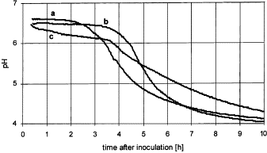

###### Figure 1: pH profiles with incubation temperature during the fermentation process of yogurt made from optimally heat treated, whey powder fortified skim milk, after inoculation with (a) a typical starter culture for stirred type yogurt, (b) a Bifidus starter culture and (c) a ropy strain starter culture. Brabandere and Baerdemaeker (1999).

Bautistia *et. al* (1966) shows the symbiotic relationship between *Lactobacillus bulgaricus* and *Streptococcus thermophilus*. Figure 2 compares the production of acid by each bacteria alone and both together.

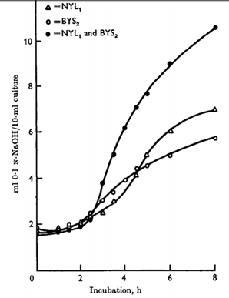

###### Figure 2: Acid Production by L. bulgaricus (NYL1), Str. thermophilus (BYS2) and their combination. Bautistia et. al (1966).

Bautistia *et. al* (1966) collected data on howStreptococcus acid production is affected by additions of glycine, histidine, and both together. Alone and with glycine, histidine increased the amount of acid produced by *Str. thermophilus* BYS2. Glycine alone did not affect acid production. With five other strands of *Str. thermophilus*, Bautista *et. al* confirmed that histidine alwayscan stimulate the bacteria but glycine and valine do not although other literature has found valine to be beneficial in increasing acid production. According to Sandine and Elliker (1970), Lactobacillus activity helps to produce glycine, histidine, and valine.

Amirdivani and Baba (2011) concocted a starter culture with a total of eight bacteria—*Lactobacillus acidophilus* LA-5, *Bifidobacterium* *bifidum* Bb-12, *L. casei* LC-01, *Streptococcus thermophilus* Th-4, *L. bulgaricus*, *L. rhamnosus*, *B. infantis,* and *B. longum*.

Ostlie *et. al* (2005) utilized *Lactobacillus acidophilus* La5, *Lb. acidophilus* 1748, *Lb. johnsonii* LA1, *Lb. rhamnosus* GG, *Lb. reuteri* SD 2112, and *Bifidobacterium animalis* BB12. For each bacterium, the study monitors pH, cfu, citric acid, lactic acid, acetaldehyde, ethanol, acetoin, and carbon dioxide for 48-hour fermentation processes at three different temperatures. From Ostlie *et. al* (2005), figure 3 gives an example of the colony forming units (cfu) measured outputs from this study.

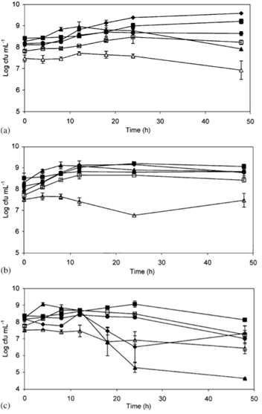

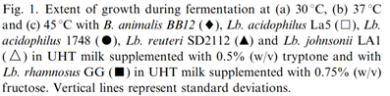

###### Figure 3: Fermentation of Lactic-Acid Bacteria Varying Temperature. Ostlie et. al (2005).

#### Products

Sandine and Elliker (1970) relates the presence of compounds, such as lactic acid, carbon dioxide, and carbonyl compounds, to flavor and aroma of dairy products. In yogurt, important flavors stem from lactic acid, acetic acid, acetone, acetoin, and acetaldehyde. From Ostlie *et. al* (2005), figure 4 shows the lactic acid concentration produced by various bacteria throughout yogurt fermentation.

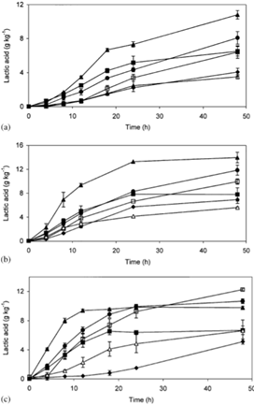

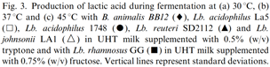

###### Figure 4: Lactic Acid Production during Yogurt Fermentation Varying Temperature and Bacteria. Ostlie et. al (2005).

#### Initial State of Culture

Chandan and Kilara (2013) details the majority of acceptable methods for storing starter culture until fermentation begins. The starter culture may be fresh, frozen, concentrated, freeze-dried, or pelletized.

Ostlie *et. al* (2005) details making 10x concentrated cultures frozen at -80C. The frozen cultures were 1% of the volume of the initial fermentation material. Kailasapathy, K. (2006) used freeze-dried probiotic cultures and yoghurt starter cultures. The study compares free bacteria with calcium-induced alginate–starch encapsulated probiotic bacteria. To a set-yogurt control without any additional probiotics, the study compares yogurt made with either free or encapsulated *Lactobacillus acidophilus* and *Bifidobacterium lactis*. Summarizing findings, Kailasapathy, K. (2006) states, “Post-acidification in yogurt with encapsulated probiotic bacteria was slower compared to yogurt with free probiotic bacteria. More exopolysaccharides were observed in yogurts with probiotic cultures compared to those without probiotic cultures. The results showed that there was an increased survival of 2 and 1 log cell numbers of L. acidophilus and B. lactis, respectively due to protection of cells by microencapsulation. The addition of probiotic cultures either in the free or encapsulated states did not significantly affect appearance and colour, acidity, flavour and after taste of the yogurts over the storage period.”

#### Additives

Common additives to yogurt fermentation are milk proteins, gelatins, and starches. Brabandere and Baerdemaeker (1999) show that varying amounts of dry matter fortification did not significantly affect the pH development. Their experiments included either skim milk powder, sodium caseinate (Protevit S), whey powder, gelatin (Rousselot P101-800), or starch (Resistamyl E-2). Modler and Kalab (1983) fortified skim milk with sodium caseinate, milk protein concentrate, skim milk powder, or three kinds of whey protein concentrate to bring the final protein content to 5%. With a lesser degree of micelle fusion observed in the microstructure, yogurts prepared with whey protein concentrates were generally softer and exhibited syneresis more than yogurt with casein-based ingredients.

Amirdivani and Baba (2011) collected data on yogurt fermentation with added herbal water from dill, peppermint, and basil. With a total of eight bacteria—*Lactobacillus acidophilus* LA-5, *Bifidobacterium* *bifidum* Bb-12, *L. casei* LC-01, *Streptococcus thermophilus* Th-4, *L. bulgaricus*, *L. rhamnosus*, *B. infantis,* and *B. longum*—in the starter culture, the study compared the rate of the pH decline of plain yogurt to that of the three herbal yogurts. During fermentation time 90-240 minutes, the plain yogurt decreases linearly at 0.4 pH per hour. In comparison, the herbal yogurts decrease faster at 0.6 pH per hour from 90-180 minutes but then slow to a 0.3 pH reduction per hour for 180-240 minutes. All three herbal yogurts reach the goal pH of 4.5 faster than the plain yogurt. Amirdivani and Baba also drew conclusions about the impacts of herbal yogurt on nutrition, including beneficial antioxidant and ACE-I inhibition activity.

Zoidou *et. al* (2017) explored adding a derivative of olive leaf, oleuropein, to the fermentation process. Against a control of plain yogurt, the product had comparable pH, titratable acidity, and growth of bacteria. The olive yogurt showed improved firmness, viscosity, and water-holding capacity over the control, and the product scored well among consumers.

Quereshi *et. al* (2011) tested over 15 days of storage the properties of yogurt fermented with garlic powder at various concentrations. The starter culture included garlic powder with *Lactobacillus spp*. The physicochemical analysis compared to plain yogurt literature values showed proteins, total solids, fat, and lactose all increased while moisture content decreased. Overall, nutritional value in garlic-based yogurt is greater than plain yogurt.

### Equipment

#### Batch Process

Bylund (1997) describes the roles and capabilities of process tanks. One example is balance tanks, which provide constant inlet pressure to pumps. Equipment differs between set and stirred yogurt. Set yogurt is fermented cup-by-cup whereas stirred yogurt ferments a large amount of material in the same container before filling cups.

#### Continuous Process

In addition to the investment in the physical capital, Driessen *et. al* (1977a) notes, “larger cultivation tanks cause variations in the final acidity” whereas a continuous fermentation process, when properly controlled, makes use of smaller equipment in a more efficient manner. Driessen *et. al* (1977b) describes a plug-flow fermenter where coagulation occurs continuously from the bottom toward the top of the tank. Driessen *et. al* (1977b) describes one drawback of a continuous process,“It is a well-known fact that coagulating milk adheres to stainless steel. On those parts of the wall on which adhesion takes place, the formation of the yogurt texture will be damaged during the movement of the coagulating milk and syneresis will occur. The remaining milk protein also forms a base for a further build-up, and the wall of the coagulation tank therefore had to be coated with materials which prevent adhesion.”

As a result, the study coated the tank with lecithin, which is successful at preventing adhesion up to certain flow velocities. Another piece of equipment involved in the continuous fermentation process is a horizontal plate with holes that is moved upward through the coagulum in order to stir the product.

MacBean *et. al* (1979) performs an analysis of a pH-stat fermenter, a continuous cultivator in which the feed rate is controlled to maintain a constant pH; therefore, the vessel always contains the desired end-product acid concentration. To achieve steady-state with regard to the presence of bacteria, the individual growth rates must be equal to the dilution rate.

#### Monitoring pH

Because yogurt fermentation processes are closely tied to pH, having the appropriate instrumentation to monitor pH is imperative for understanding and controlling the process.

MacBean *et. al* (1979) performs an analysis of a pH-stat fermenter, a continuous cultivator in which the feed rate is controlled to maintain a constant pH; therefore, the vessel always contains the desired end-product acid concentration. Brabandere and Baerdemaeker (1999) utilized a calibrated pH probe (Orion Ag/AgCl 9102SC or Orion Ag/AgCl Sure-Flow 9165BN, Orion, Boston, USA) and a temperature compensating probe (Orion 917005). In their study manipulating several fermentation variables, pH was measured every 120 seconds. At the end of the monitoring the fermentation, and without a recalibration, a control measurement of the pH of the buffer 7.00 (Orion 910107) and the buffer 4.01 (Orion 910104) solution was performed. The purpose of the concluding control measurement was to evaluate drift of the pH meter overtime, and drift was determined to be insignificant. Ostlie et. al (2005) reports,“All pH measurements were made during fermentation using a Radiometer (pHM 92) pH meter with a combined glass electrode and temperature probe (Radiometer, Copenhagen, Denmark). The pH meter was calibrated using standard buffer solutions (Merck) at pH 4.0 and 7.0.”Amirdivani and Baba (2011) read pH using a digital meter (Mettler-Toledo 320, Shanghai). Kailasapathy, K. (2006) used a TPS Digital pH meter (Denver Instruments, USA) calibrated with buffer solutions of pH 7.0 and 4.0. The technique for testing pH was such that the yogurt sample was stirred with distilled water before pH measurement.

### Conclusion

The symbiotic relationship of *Lactobacillus bulgaricus* and *Streptococcus thermophilus* is well-understood, but with the emergence of new strains and species of yogurt probiotics, the interactions between bacteria and types of milks should continue to be explored. Given the nearly endless possibilities for strains of lactic-acid bacteria, processed milks, and their combinations, yogurt fermentation research can advance indefinitely. Ostlie *et. al* (2005) shows the most comprehensive description of behaviors of six unique lactic-acid bacteria throughout fermentation. With each bacterium, their study monitors pH, cfu, citric acid, lactic acid, acetaldehyde, ethanol, acetoin, and carbon dioxide for 48-hour fermentation processes at three different temperatures. Optimizing fermentation processes and maximizing human health and economic benefits should be prioritized.

Encapsulation is a recent development to maximize probiotic benefits. Types of capsules should continue to be developed and evaluated. Non-traditional food additives is an emerging market for both consumers and yogurt manufacturers. Considering spray-dried yogurt, research should continue on how the food additives affect the ability of the yogurt to be preserved as a powder and reconstituted. The food science community can benefit from evaluating which fermentation additions are most efficient for the manufacturer and which are best suited for consumers.

Although research developed a method of continuous yogurt processing several decades ago, current research typically makes use of a batch process. Further process improvements to the continuous yogurt process and conclusions about their impact on efficiency should be incorporated into research.

Several methods of monitoring pH occur across the industry. All pH-monitoring technologies reviewed seem relatively successful, but the instruments’ accuracy within ranges of temperature and pH specific to yogurt culture should be prioritized. Reducing clogging and cleaning of the probe is ideal, and choosing a probe that interacts well with both aqueous and viscous solid parts of yogurt in the event of syneresis is advised.

## Spray Drying

### Goals of Spray Drying

Spray drying is a process in which a product is converted from a liquid to a powder by removing moisture from the product. The product is atomized and exposed sprayed into a chamber of hot air which removes the water content from the product without allowing it to reach a temperature higher than the wet bulb temperature of the drying air (Okos, Drying Equipment, 2018). This process is beneficial for industrial production and storage of products because it increases the shelf-life of the product without requiring refrigeration, which also reduces the cost of shipping (Yilmaz, Sert, & Karakaya, 2010; Bylund, 2003). In addition, because the product never reaches a very high temperature, there is minimal damage to the microstructure due to heating, leading to a high-quality product following rehydration (Rascon-Diaz, Tejero, Mendoza-Garcia, Garcia, & Salgado-Cervantes, 2012; Yilmaz, Sert, & Karakaya, 2010).

### Methods

Spray drying is one of the principal methods of drying in the dairy industry. The process works by concentrating the milk via evaporation then drying in a spray tower (Bylund, 2003). There are three steps in the process of spray drying. First, the yogurt is atomized, then the droplets are dried in the heated air for three to 30 seconds, and finally, the particles are separated from the hot air. The liquid yogurt is atomized with a rotating wheel atomizer which spins or a pressure nozzle, pulling in the product to the center with centrifugal force. Droplet shape is determined by the shape of the vanes in the wheel and the rotational speed of the wheel (Equation 1, (Okos, Campanella, Narsimhan, Singh, & Weitnauer, 2007)) or the pressure drop across the spray nozzle (Equation 2, (Okos, Campanella, Narsimhan, Singh, & Weitnauer, 2007)). Rotating wheel atomizers produce particles in the range of 1-600 μm and pressure nozzles produce particles in the range of 10-800 μm (Okos, Campanella, Narsimhan, Singh, & Weitnauer, 2007).

###### Equation 1

$D_{a}=12.2e^{4}r(\frac{Γ}{p_{1}Nr^{2}})^{0.6}(\frac{μ}{Γ})^{0.2}(\frac{αp_{1}L}{Γ^{2}})^{0.1}$

###### Equation 2

$D_{a}=(\frac{500}{ΔP})^{\frac{1}{3}}$

### Process Inputs and Outputs

The yogurt entering a spray drying process has very strict requirements on the number of bacteria per gram; the final dried product must not exceed 50,000 bacteria per gram, or 5,000 bacteria per liter once reconstituted. This is especially important for heat-resistant bacteria as they may multiply during evaporation and change the balance of the probiotics in the yogurt (Bylund, 2003). The final powder product has a protein content of 33 to 36%, an increase from an average of 22% prior to drying (Gerdes, 2009).  
 The outlet temperature of the air into the drying column is the most important factor that affects the properties of the yogurt, including the survival of bacteria and color change. A lower air temperature, specifically 60.5°C, was significantly correlated with the ideal qualities of the final product (Koc, Sakin-yilmazer, Kaymak-ertekin, & Balkir, 2014). This does, however, mean that the droplets must stay for a longer period of time in the dryer.

### Effect of Spray Drying on Product

Spray drying produces particles that are mostly spherical with crater-like structures. The particle size distribution is normal with a peak of 3.053 μm. The particles are highly soluble (68.7%), dense (538 kg/m3), and somewhat porous (36.54%). When drying with very hot air (85°C), it was noted that the sensory properties, specifically color, changed and were less accepted by consumers (Koc, Sakin-yilmazer, Kaymak-ertekin, & Balkir, 2014).   
 Traditional yogurt typically lasts two to three weeks before spoiling. One study found using sorption isotherms, however, that powdered yogurt will have more than double the shelf life of traditional yogurt (Dibyakanta, Dash, Mishra, & Deka, 2018). The authors determined adsorption isotherms of a spray-dried yogurt powder with static gravimetric technique at four different temperatures and fit the data to eight sorption models. The GAB model was used to find the moisture content at each temperature. The heat of sorption and Gibbs free energy change were also calculated. The powder’s storage stability was studied in two types of packaging and it was found that the shelf life of powdered yogurt can reach up to 45 days in aluminum laminated polyethylene packaging.   
 In addition to the shelf life being affected by the increased air temperature, research has shown that the number of microorganisms in the yogurt decreases with increased air temperature as well as the increased pressure drop across the pressure nozzle. The ideal conditions for producing acceptable dried particles while retaining survival of two bacterial species, *Streptococcus salivarius thermophilus* and *Lactobacillus debrueckii bulgaricus*, were found to be an air temperature of 60°C and a pressure drop of 98 kPa across the atomizer. These conditions are not perfect, however, as freeze-drying was found to have a higher survival rate for these specific bacterial species (Kim & Bhowmik, Survival of lactic-acid bacteria during spray drying of plain yogurt, 1990). A similar study found that the air temperature of 60°C was also the optimal temperature for retaining lactic acid bacteria and other sensory attributes including color and moisture content (Koc, Yilmazer, Balkir, & Ertekin, Spray Drying of Yogurt: Optimization of Process Conditions for Improving Viability and Other Quality Attributes, 2010).   
 The two main flavor components of yogurt, acetaldehyde and diacetyl, are heat sensitive and can degrade during the drying process. As spray drying requires a lower temperature than most drying processes, this is not a large concern, but it was found that the flavor of the dried yogurt was improved when whey protein concentrate was added to the yogurt during the fermentation process when the pH reached 4.6. This increased the acetaldehyde content of the yogurt to offset the losses created during spray drying (Anonymous, 2005).

### Alternative Drying Methods

#### Freeze-Drying

Freeze-drying is a method by which a product is frozen and then the pressure is reduced during heating to allow the ice in the material to sublimate. This method is advantageous for drying yogurt because it creates a more nutritious product with a similar texture to normal yogurt once it is rehydrated than other methods of drying. In addition, the process has a higher rate of survival of critical bacteria survival than spray drying, specifically lactic acid bacteria. Finally, it is more widely accepted by consumers than other forms of dried yogurt, it can dry yogurt products with added ingredients such as fruit or nuts, and it has a longer shelf-life, so it is ideal for industrial processing of yogurt for sale (Sakin-yilmazer, Dirim, Di Pinto, & Kaymak-ertekin, 2014).   
 However, freeze-drying is more expensive than other drying processes (Kim & Bhowmik, Moisture Sorption Isotherms of Concentrated Yogurt and Microwave Vacuum Dried Yogurt Powder, 1994). It also creates a product with a lower moisture content, which can increase the rates of spoilage reactions due to the higher reactant concentrations. Finally, while it retains a higher number of lactic acid bacteria than other forms of drying, it still loses some colonies compared to traditional yogurt (Kim & Bhowmik, Survival of lactic-acid bacteria during spray drying of plain yogurt, 1990).

#### Microwave Vacuum Drying

Microwave drying is a process by which microwave radiation generates heat as the pressure of the chamber is reduced (Scaman, Durance, Drummond, & Sun, 2014). It is advantageous as it has a lower spoilage rate as compared to traditional yogurt because of a lower level of equilibrium moisture content (Kim & Bhowmik, Moisture Sorption Isotherms of Concentrated Yogurt and Microwave Vacuum Dried Yogurt Powder, 1994). However, the differences between microwave vacuum drying and other forms of drying are not very significant when drying yogurt specifically (Sengupta & Bhowal, 2017). Additionally, as this is a new technology, the equipment is much more expensive than that of more traditional methods (Scaman, Durance, Drummond, & Sun, 2014).

#### Refractance Window Drying

Refractance window drying is a process which is advantageous as it has better physical properties than freeze-dried yogurt. In addition, it requires a lower production temperature than spray-drying, which also infers that the physical properties will not be affected by heat (Tontul, Ergin, Eroglu, Kucukcetin, & Topuz, 2018). However, the dried yogurt product has a less pleasing color and the yogurt bacteria counts are lower than dried yogurt produced by other methods (Tontul, Ergin, Eroglu, Kucukcetin, & Topuz, 2018).

### Conclusions

Spray drying is the industrial standard process for creating dehydrated dairy products. Though it has a negative effect on the sensory properties and survival of important probiotic bacteria, it is efficient and effective for creating a yogurt product with a longer shelf life. Additionally, steps can be taken in earlier processes of the yogurt creation to counteract the detrimental effects of spray drying on the yogurt product. The literature consistently shows that the optimal temperature of the air to heat the droplets of yogurt while causing minimal damage on the product is 60°C and the pressure drop across the spray nozzle should be about 98 kPa.

## Recipe and Ingredients

### Product Ingredients / Functionality

###### Table 1: Ingredient Functionality

|  |  |
| --- | --- |
| *Ingredient* | *Functionality* |
| Reduced-fat milk | fermentation reactant |
| Corn Starch | stabilizer |
| Live Culture (*S. thermophylus* and *L. bulgaricus*) | Lactose fermentation |
| Milk powder | Protein additive / stabilizer |
| Strawberries | Flavor / texture improvement |

### Product Recipe and Steps

#### Milk Fortification and Preparation

The main component of yogurt is milk. Modification of milk composition prior to fermentation is used to achieve different variants of yogurt. To decrease the fat content of the yogurt, the milk is clarified and milk fats are separated out from the liquid. Cream can be added to increase fat content and thicken the yogurt. Protein supplementation can be achieved by adding nonfat dry milk to the liquid. Stabilizers such as gelatin, pectin, or starch are used to increase product viscosity and homogeneity. After modifying the milk composition, the liquid is pasteurized and homogenized to sterilize the fluid, denature the milk proteins, and create a smoother and creamier end product. The product is cooled to prepare for the next step of the procedure.

This recipe will use milk supplemented with milk powder and a cornstarch stabilizer to produce a fortified yogurt. The fortified product will be heated to denature proteins and kill any contaminants. Subsequent cooling will prepare the milk for fermentation.

#### Fermentation

During production, milk is fermented into a curd with the help of a bacterial culture. This fermentation process creates a characteristic yogurt flavor and gel-like consistency. Yogurt fermentation typically utilizes one of two bacterial cultures over a three to four hour incubation period. Fermentation is accompanied by agitation and proceeds until the required pH and acidity values are reached. The National Yogurt Association sets 108 organisms/g as the minimum number of live lactic-acid bacteria that should exist at the time of manufacture through the stated shelf life (Adolfsson et al., 2004). After the pH, acidity, and organism specifications are met, the product is cooled to halt fermentation.

A combination of *S. thermophilus* and *L. bulgaricus* will act as the starter culture for this fermentation process. Incubation and agitation will proceed at 42ºC for 3-4 hours or until the desired consistency, pH, and acidity are achieved. Cooling the yogurt product will halt the fermentation process.

#### Supplementation and Dehydration

At this point, the yogurt can be supplemented with different flavors to improve taste and texture. A chocolate or fruit additive will be mixed into the yogurt at this point to sweeten the product and improve flavor. Dehydration can be achieved using a spray-drying technique that allows the bacteria to live (Kim and Bhowmik, 1990). Milk is used to reconstitute the product prior to consumption.

# Mass and Energy Balance Details

## Overall Plant Mass Balance (for one hour)

500 kg raw milk + 2385.5 kg steam + 1505.35 kg Dry Air + negligible starter culture + 939 kg chilled water+8 kg lactose→ 2385.5 kg steam +222.4 kg Concentration Waste +48.13 kg Dried Yogurt + 1741.54 kg Humid Air + 939 kg water

## Gantt Chart

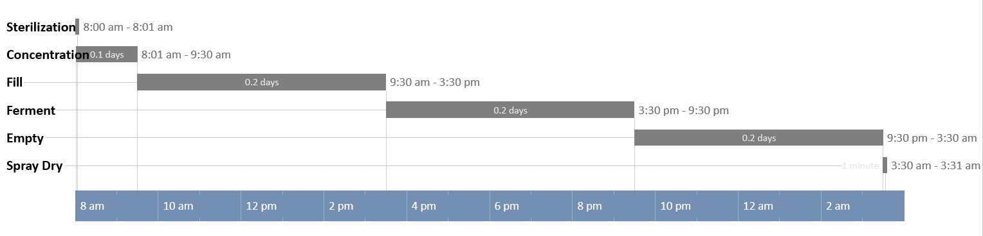

###### Figure 5: Gantt Chart for one particle of milk throughout the yogurt-making process.

## Processing Steps with Mass Balances

### Sterilization

#### Regenerative Heating

##### Methods

A regenerative process is used where the heat-treated milk is used to preheat the raw milk input, and the raw milk is used to cool down the pasteurized milk. In this way, the heat can be recycled saving in energy costs. A positive displacement pump is also placed after the plate heat exchanger so that there is higher pressure on the product stream, so if there is a leak, the product will leak into the raw stream. The sterilized milk is also cooled so that proteins are not denatured (Bylund, 1995).

##### Mass Balance

Mass of raw milk + Mass of sterilized milk -> Mass of preheated milk + Mass of cooled milk

500 kg raw milk + 500 kg sterilized milk -> 500 kg preheat milk + 500 kg cooled milk

Temperature: 50oC

Time: 1 minute

Ingredients: 500 kg of raw milk

#### Pasteurization

##### Methods

The milk is heat treated to remove harmful pathogens and removal of microorganisms that can spoil the taste and shorten the shelf life of milk products (Bylund, 1995). High-temperature short time (HTST) pasteurization is used in a plate heat exchanger to heat the milk to 80 C. This is a continuous process that heats up the milk rapidly and keeps it in a holding tube for a residence time of at least 15 seconds to effectively destroy the pathogens (Aguiar, 2014).

##### Mass Balance

Mass of preheated milk + Mass of steam -> Mass of sterilized milk + Mass of steam

500 kg preheat milk + 2358.5 kg of steam -> 500 kg sterilized milk + 2358.5 kg of steam

Temperature: 80oC

Time: 1 minute

Ingredients: 500 kg of preheated milk

### Concentration

#### Methods

The sterilized milk passes through a microfiltration system to concentrate the stream and remove water and whey protein from the solution. This step increases the density and casein protein content of the final product. Microfiltration pores range from 0.1-10 uM, meaning water, salts, lactose, and whey protein pass through the membrane, while the large casein proteins remain within the retentate stream. The spiral-bound crossflow microfiltration system removes 65+% of whey protein and water from the concentrated milk stream. Additional filtration steps could be used to further reduce the final whey percent, however, this filtration step also removes lactose from the concentrated milk stream. Lactose is required for the subsequent fermentation step, so the concentration step is limited to ensure adequate lactose remains in the stream. This industrial microfiltration system is upright and powered by a small pressure differential and a centrifugal pump with a fluid velocity of 0.6 meters per second.

Temperature: 50oC

Time: approximately 90 minutes (4-hour absolute max to maintain protein stability)

Ingredients: Sterilized Milk

#### Mass Balance

Mass of Sterilized milk -> Mass of Concentrated Milk + Waste

500 kg Sterilized Milk -> 277.6 kg Concentrated Milk + 222.4 kg Waste

##### Further Breakdown into Mixture Components

435 kg water + 65 kg SNF -> (239 kg water + 38.6 SNF) + (196 kg water + 26.4 kg SNF)

Incoming SNF: 33.9 kg lactose + 20.3 kg casein + 4.9 kg whey + 0.7 kg fat + 5.2 kg ash

Outgoing SNF (milk): 10.8 kg lactose + 20.3 kg casein + 1.6 kg whey + 0.7 kg fat + 5.2 kg ash

Outgoing SNF (waste): 23.1 kg lactose + 3.3 kg whey

### Fermentation

#### Method

Yogurt is fermented with lactic acid bacteria *Lactobacillus bulgaricus* and *Streptococcus thermophilus* in a symbiotic relationship (Bautistia *et. al* 1966). The fermentation occurs at 40oC until a pH of 4.2 is reached, which takes about 6 hours, to ensure all proteins have coagulated at or below their isoelectric point of pH ~4.6. Lactose from milk breaks into glucose and galactose. In a 1: 2-mole ratio, glucose becomes lactic acid.

This process includes three fermentation tanks such that at any given time, one is fermenting, one is filling with milk, and one is emptying yogurt to the spray dryer. The thin layer of material stuck to the sides of the stainless steel fermentation tank is considered negligible. A sweep CIP occurs at the end of emptying. Because this process begins with an input of 500kg/h of milk, the tanks are 3500L of which just over 3000L will be occupied by the fermenting yogurt. The headspace leaves room for extra material if one tank needs to fill beyond 6 hours if the fermenting tank has not reached pH 4.2 in 6 hours (assuming it does so before 7 hours). The tank is not stirred.

From the concentration step, the milk is run through a countercurrent shell-and-tube heat exchanger where the milk becomes 40oC and the cooled water, originally 10oC becomes 40oC. That water is fed into the water jacket of the filling tank in order to roughly maintain the 400C fermentation setpoint temperature. Water from the sterilization step at 44oC is fed into the jacket of the fermenting tank such that the yogurt will maintain within 10% of the setpoint of 40oC.

Temperature:

* Inlet fermentation water jacket (from sterilization step): 44oC
* Inlet yogurt: 50oC
* Inlet chilled water: 10oC
* SuperPro inlet chilled water: 5oC
* Outlet chilled water/inlet water jacket: 40oC
* SuperPro outlet chilled water: 10oC
* Fermenting yogurt: 40oC
* Outlet yogurt: 15oC

Time: 6-hour fermentation

Ingredients: Concentrated milk, starter culture

#### Mass Balance

277.6 kg Concentrated Milk + 939 kg chilled water + negligible starter culture + 8kg extra lactose → 285.6 kg Fermented Yogurt + 939kg water

Within concentrated milk, if the reaction is assumed to go to completion:

10.8 kg lactose → 5.7 kg glucose → 5.7 kg lactic acid

With extra lactose, if the reaction is assumed to go to completion:

18.8 kg lactose → 9.9 kg glucose → 9.9 kg lactic acid

### Drying

#### Method

The yogurt is converted from a liquid to a powder via atomization before being sprayed into a chamber of hot air which removes the water content from the product without allowing it to reach a temperature higher than the wet bulb temperature of the drying air.

Temperature:

* Inlet Air: 171 °C
* Feed Inlet: 15 °C

Time: continuous process over one hour

Ingredients: Yogurt, Dry Air

#### Mass Balance

Mass of Fermented Yogurt + Dry Air -> Mass of Dried Yogurt + Humid Air

285.6 kg Fermented Yogurt + 1505.35 kg Dry Air -> 48.13 kg Dried Yogurt + 1741.54 kg Humid Air

##### Further Breakdown into Mixture Components

(239 kg water + 5.7 kg lactic acid + 5.7 kg galactose + 20.3 kg casein + 1.6 kg whey + 0.7 kg fat + 5.2 kg ash) + 1505.35 kg air -> (2.81 kg water + 5.7 kg lactic acid + 5.1 kg galactose + 20.3 kg casein + 1.6 kg whey + 0.7 kg fat + 5.2 kg ash) + (1505.35 kg air + 236.19 kg water)

## Processing Steps with Energy Balances

### Sterilization

#### Regenerative Heating Energy Balance

Energy in raw milk + Energy in sterilized milk = Energy out preheat milk + Energy out cooled milk

(Energy in raw milk - Energy out preheat milk) = (Energy out preheat milk - Energy in sterilized milk)

Change in the energy of milk = Change in the energy of milk

mmilk * cp,milk * dTmilk,raw = mmilk * cp,milk * dTmilk,sterilized

**Tmilk, preheat = 34 C** (assuming sterilized milk leaves at 50 C)

mfrmilk * cp,milk * dTavg = U * AHX * dTsterilized,milk

**AHX = 0.00315 m2** (U = 267 W/m2K)

#### Pasteurization Energy Balance:

Energy in sterilized milk + Energy in cold water = Energy out warm milk + Energy out cold water

(Energy in sterilized milk - Energy out warm milk) = (Energy out cold water - Energy in cold water)

Change in the energy of milk = -Change in the energy of water

mmilk * cp,milk * dTmilk = msteam * cp,steam * dTsteam

**mfrsteam = 39.3 kg/s** (assuming 1 minute to heat milk from 34C to 80C)

mfrsteam * cp,steam * dTavg = U * AHX * dTsteam

**AHX  = 1.85 m2** (U = 267 W/m2K)

### Concentration

#### Energy Balance

The major energy expenditures for the filtration system are the pressure differential and the height difference of the upright system. The system will be powered by a centrifugal pump.

﻿∆Potential Energy + ∆Enthalpy = Shaft Work

$\underline{m}* g* h +ΔP*A{}_{membrane}*v = \underline{W{}_{s,on}}$

**Ws, on = 30,000kJ total** (Energy requirement for the pump powering membrane filtration system)

h = 2.5 m

∆P = 50,000 Pa (0.5 bar, which is normal for a microfiltration pressure differential)

**Amembrane = 100 m2**

### Fermentation

#### Energy balance for countercurrent cooling to 40C

Milk at 50oC + water at 10oC → Milk at 40oC + water at 40oC

277.6 kg/h * 3.93 kJ/kgK * (50-40)= mwater kg/h *4.1855 kJ/kgK *(40-10)

mwater = 86.9 kg/h

$m_{water}C_{p,w}ΔT_{w} = UAΔT_{ln} =$ 10909.7 KJ/h = 3030.5 J/s

$ΔT_{ln}$ = 10 - 30 / ln(⅓)

where U is ~1700 W/m2K from Geankoplis pg 300, A = 0.098 m2

#### Super Pro energy balance for countercurrent cooling to 40oC

Milk at 50oC + water at 5oC → Milk at 40oC + water at 10oC

277.6 kg/h * 3.93 kJ/kgK * (50-40)= mwater kg/h *4.1855 kJ/kgK *(10-5)

mwater = 521.3 kg/h

$m_{water}C_{p,w}ΔT_{w} = UAΔT_{ln} =$ 10909.7 KJ/h = 3030.5 J/s

$ΔT_{ln}$ = 40 - 35 / ln(40/35)

where U is ~1700 W/m2K from Geankoplis pg 300, A = 0.048 m2

#### Energy Balance for filling and fermenting tank for 6 hours

Inside the fermentation tank, no heat loss to the environment is assumed since Heisler charts show for any Biot number that the Fourier number would have to be quite large to experience any significant drop in temperature. Even in 6 hours, the Fourier number, dimensionless time, is 0.0108, which is not large enough for any significant temperature drop. Additionally, the filling tank has a steady flow of 40oC water to insulate from the surrounding ambient air.

Milk at 40oC + negligible heat from bacterial respiration → Yogurt at 40oC

#### Energy Balance for emptying tank for 6 hours:

No running water jacket, so the material can begin to equilibrate with ambient air.

#### Energy balance for countercurrent cooling to 15C

Yogurt at 40oC + water at 10oC → Yogurt 15oC + water at 25oC

285.6 kg/h * 3.93 kJ/kgK * (40-15)= mwater kg/h *4.1855 kJ/kgK *(25-10)

mwater = 434.4 kg/h

$m_{water}C_{p,w}ΔT_{w} = UAΔT_{ln} =$ 27274.2 KJ/h = 7576.1 J/s

$ΔT_{ln}$ = 15 - 5 / ln(15/5) = 9.1

where U is ~1600 W/m2K from Geankoplis pg 300, A = 1.87 m2

#### Super Pro energy balance for countercurrent cooling to 15oC

Yogurt at 40oC + water at 5oC → Yogurt 15oC + water at 10oC

285.6 kg/h * 3.93 kJ/kgK * (40-15)= mwater kg/h *4.1855 kJ/kgK *(10-5)

mwater = 1303.2 kg/

$m_{water}C_{p,w}ΔT_{w} = UAΔT_{ln} =$ 27274.2 KJ/h = 7576.1 J/s

$ΔT_{ln}$ = 30 - 10 / ln(3) = 18.2

where U is ~1600 W/m2K from Geankoplis pg 300, A = 0.937 m2

### Drying

#### Energy Balance

The energy of Fermented Yogurt + Energy of Dry Air -> Energy of Dried Yogurt + Energy Humid Air

Delta Energy of Yogurt = - Delta Energy of Air

##### Energy Balance on Air

Delta Energy of Air = Delta Energy due to Temperature Change

Temperature of Air In = 171oC

Temperature of Air Out = 60.5oC

Mass of air = 1505.35 kg air

Cp of air = 1.013 kJ/kg.K

See Appendix A for calculations.

$m_{air}C_{p,air}ΔT_{air}$ = -168503.61 kJ

##### Energy Balance on Yogurt

Delta Energy of Yogurt = Delta Energy due to Temperature Change + Delta Energy due to Water Vaporization

Temperature of Yogurt + Water In = 15oC

Mass of Water Vaporized = 236.19 kg

Heat of Vaporization of Water = 581 kJ/kg

Temperature of Water Out = 60.5oC

Cp of Steam = 1.8644 kJ/kg*K

Mass of Yogurt + Water Left Over = 48.13 kg

Cp of Yogurt + Water Left Over = [see Choi-Okos Equation calculations in Appendix A]

See Appendix A for calculations

$m_{yogurt}C_{p,yogurt}ΔT_{yogurt}+$*mwaterHvap,water* = 168503.61 kJ

The temperature of Yogurt Out = 40oC

# Plackett-Burman DOE

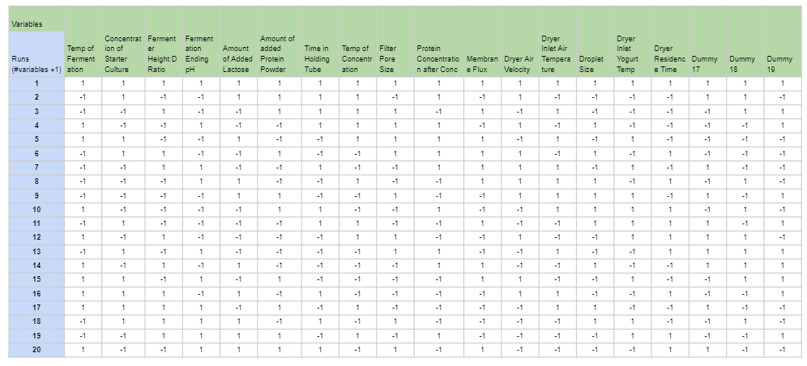

###### Figure 6: Plackett-Burman DOE. Sixteen variables and three dummy variables were used over twenty runs.

###### Table 2: Plackett-Burman DOE Minimum and Maximum Values for Each Variable

|  |  |  |
| --- | --- | --- |
| Variable | +1 | -1 |
| Fermentation Temperature | 37 | 43 |
| Starter Culture Concentration | 3% | 1% |
| Fermenter Height to Diameter Ratio | 1:1 | 3:1 |
| Fermentation Ending pH | 4.4 | 4.2 |
| Lactose Added (kg/batch) | 51 | 45 |
| Protein Powder Added (kg/batch) | 1 | 0 |
| Time in Holding Tube (sec) | 15 | 25 |
| Temperature of Concentrate (C) | 40 | 60 |
| Filter Pore Size (μm) | 0.05 | 0.2 |
| Filtration Concentration Factor | 1 | 3 |
| Membrane Flux (L/(h*m2)) | 200 | 400 |
| Dryer Air Velocity (m/s) | 0.6 | 1.5 |
| Dryer Inlet Air Temperature (oC) | 150 | 180 |
| Droplet Size (μm) | 5 | 20 |
| Dryer Inlet Yogurt Temperature (oC) | 4 | 30 |
| Dryer Residence Time (sec) | 3 | 10 |

# Unit Operations Design and Performance Curves

# Lab-Scale Experimentation

### Sterilization

Pasteurization, at the lab scale, was evaluated based on batch parameters and a streak plate to assess microbial reduction. With the equipment provided for the lab scale, a batch pasteurization method was implemented. Initially, 300 mL of skim milk was poured into a 500 mL beaker. A sample of the skim milk was taken and streaked on an LB agar plate and incubated at 37 ℃ overnight. A toaster oven heated the milk to an appropriate temperature and a power meter gave an idea of power consumption. A thermometer measured the temperature of the milk in the beaker and the ambient temperature of the toaster oven every 10 minutes. The milk needed to be heated to 65 ℃ and maintained for at least 30 minutes to eliminate pathogens and degradative enzymes. If the ambient temperature dropped below 75 ℃, then the temperature setting on the toaster was increased. The ambient temperature was set to a higher temperature than the desired to temperature to account for different resistances to heat transfer. After the milk was maintained at above 65 ℃ for at least 30 minutes, another sample was taken to be streaked on an LB agar plate and incubated 37 ℃ overnight.

When implementing the pasteurization procedure into experimentation, there were limitations with some of the equipment present. The most significant issue with evaluating the pasteurization parameters is that the skim milk used in the process was already pasteurized. It was too difficult to find raw, unpasteurized milk. The toaster oven also did not have accurate temperature control and had to be opened often to check the temperature of the milk and surroundings, which impacted the heat transfer coefficient. Lastly, LB agar plates were not present to evaluate the microbial reduction after following the pasteurization procedure. Power measurements were taken using the power meter. While the toaster oven was heating, the power meter read at 1387 W. It was estimated that the toaster oven was heating and only consuming power while the ambient temperature was increased to 75 ℃, which was 35 minutes, making the power consumption 2912 kJ.

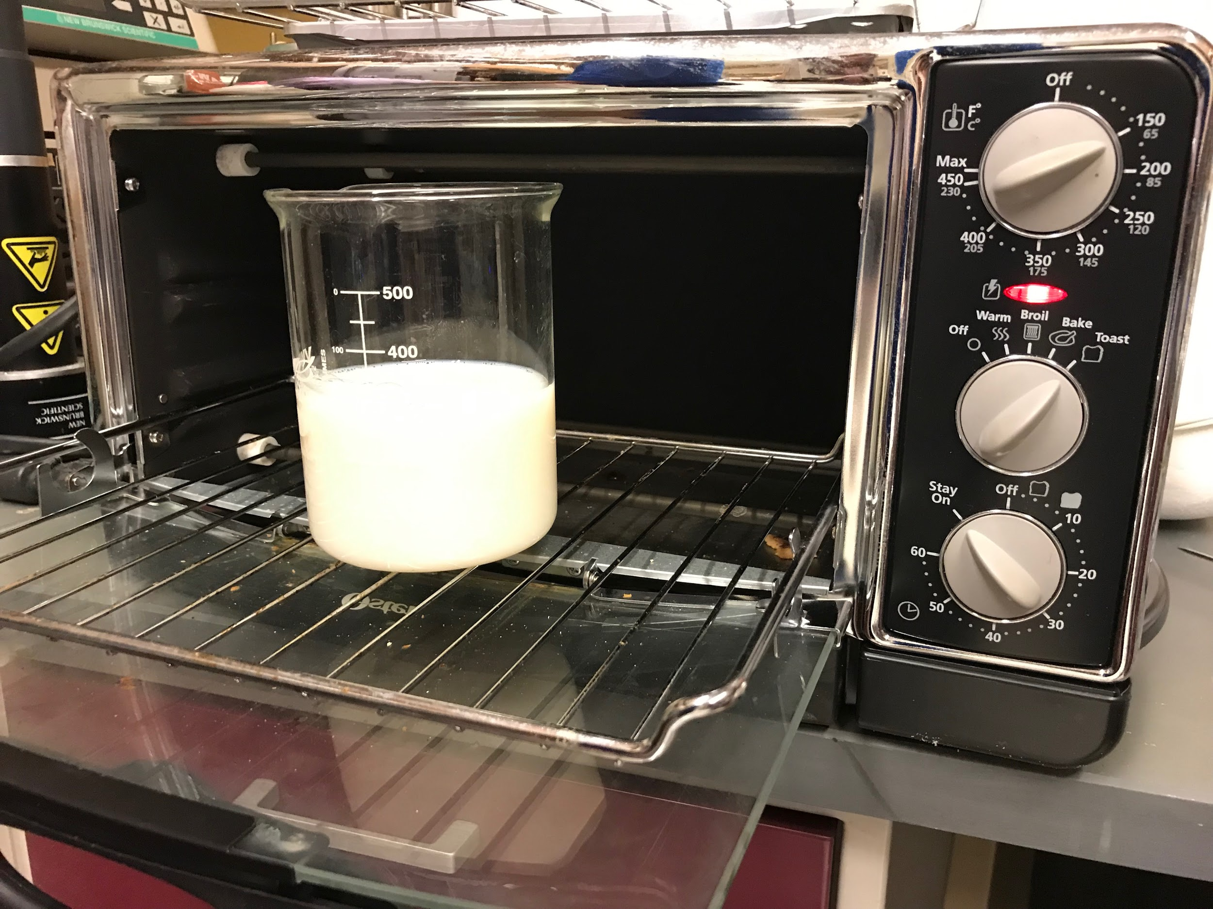

###### Figure 7: Pasteurization instrumentation showing toaster oven and beaker with skim milk

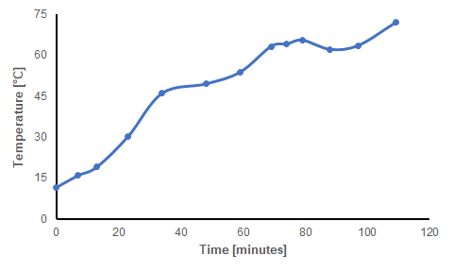

###### Figure 8: Thermal data for skim milk during pasteurization procedure

The skim milk pasteurized in the toaster oven was compared to the purchased skim milk to evaluate the quality parameters. It was desired that the pasteurization procedure would not alter sensory characteristics of the skim milk after processing and only remove the harmful microbes. The pasteurized skim milk was evaluated based on odor, consistency, and taste. The odor was enhanced in the pasteurized skim milk and smelled a bit sourer than the purchased skim milk. The consistency was equivalent between them. The experimental sample was not tasted this time due to the possibility of contamination from a previous sample left in the beaker. During further evaluations, the glassware will be cleaned prior to experimentation, so that the samples can be tasted as well.

### Concentration

The lab equipment required for the concentration step was not in an appropriate condition to perform a separation. When working, the provided ultrafiltration system depicted in Figure 9 will be used to simulate membrane filtration of the pasteurized milk. A single-pass filtration method will be used, and the retentate from the process will proceed to the fermentation step of production. The protein content of the initial and final streams will be compared to determine how well the concentration worked. Because of the variation in pore size between micro- and ultrafiltration, protein fractionation will not be achieved using this method, but the overall protein content can be tracked using the Kjeldahl Method. An additional spectrophotometry test such as an SDS-page gel can also be included to compare the amounts of separate protein species within each stream.

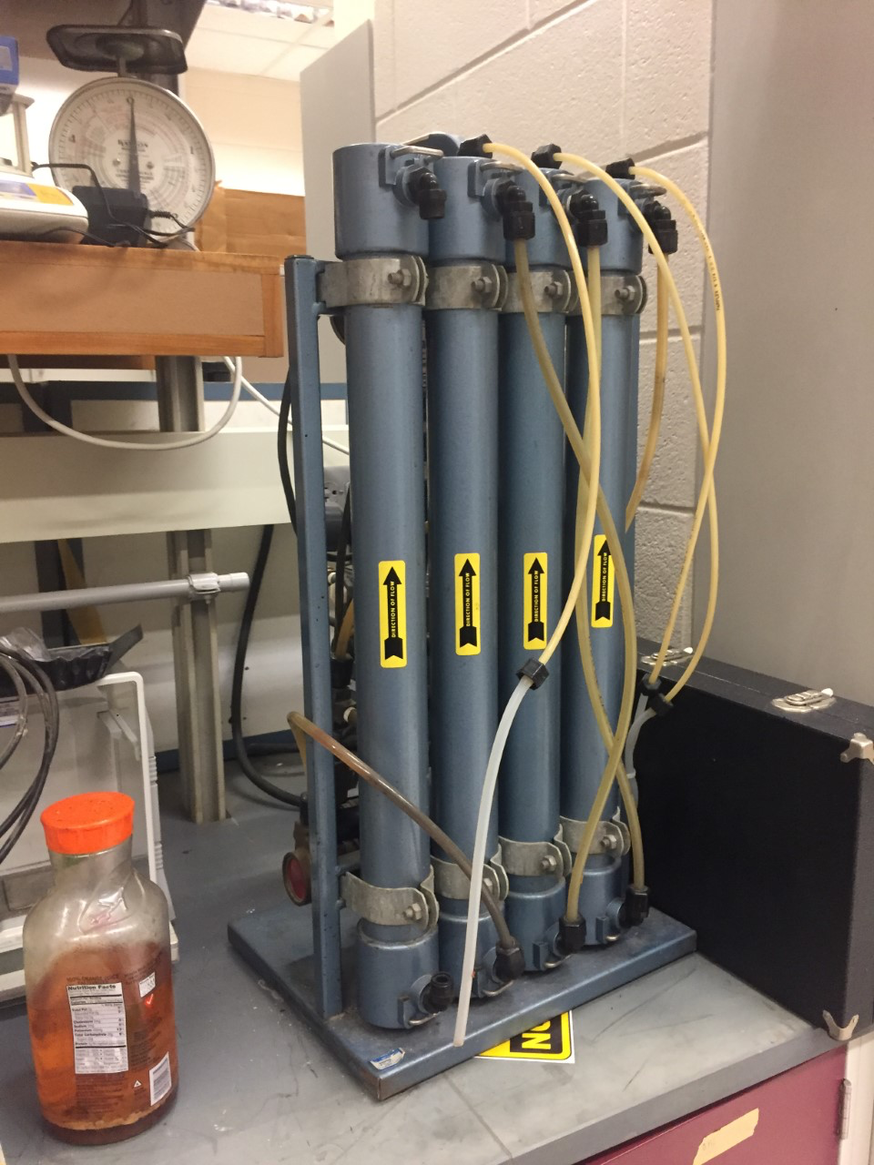

###### Figure 9: Microfiltration system for lab scale experimentation

### Fermentation

Given a limited number of hours in the lab, data collection on the full six-hour fermentation process was unrealistic, so this lab design purposefully simulated the yogurt fermentation process at varying extents based on pH. Lactic acid fermentation controls pH, a measurable quantity, and end product quality related to taste, a testable factor. Figure 10 shows the initial pH of the skim milk, Dannon yogurt, and each beaker mixture. The beakers increased in pH by about 0.2. While controlling pH by varying milk:yogurt ratios, other variables affected are: lactose concentration, starter culture concentration, and heat capacity. The exact stains and concentrations of live cultures in the yogurt could not be determined although the container mentioned live cultures, including L. acidophilus.

Neither the yogurt maker instructions, box, or the device itself indicated the operating temperature nor had a method of changing the temperature setting of the hot plate beneath the beakers. Temperature readings of the beakers indicate the hot plate setting may be 45°C. For each beaker, temperature and pH data were collected every 20 minutes during the 2 hours of fermentation.

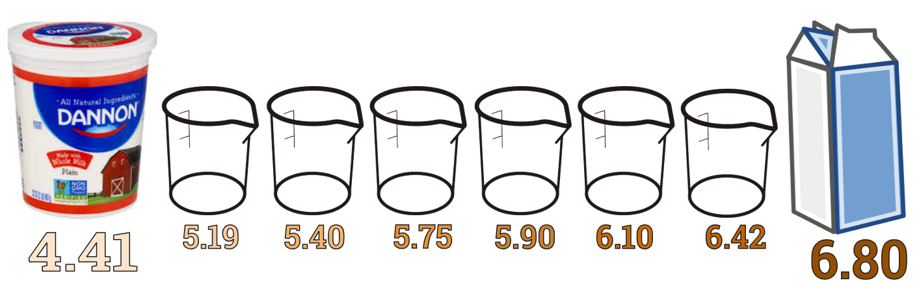

###### Figure 10: Initial pH Gradient for Lab-Scale Yogurt Fermentation

The beakers were not covered individually but were covered by a plastic lid over the entire area of the yogurt maker. Figure 11 shows an image of the six fermenting beakers in the yogurt maker. Qualitative observations include the thickening of the mixture over time and the formation of froth around the glass particularly in the beakers beginning at lower pH.

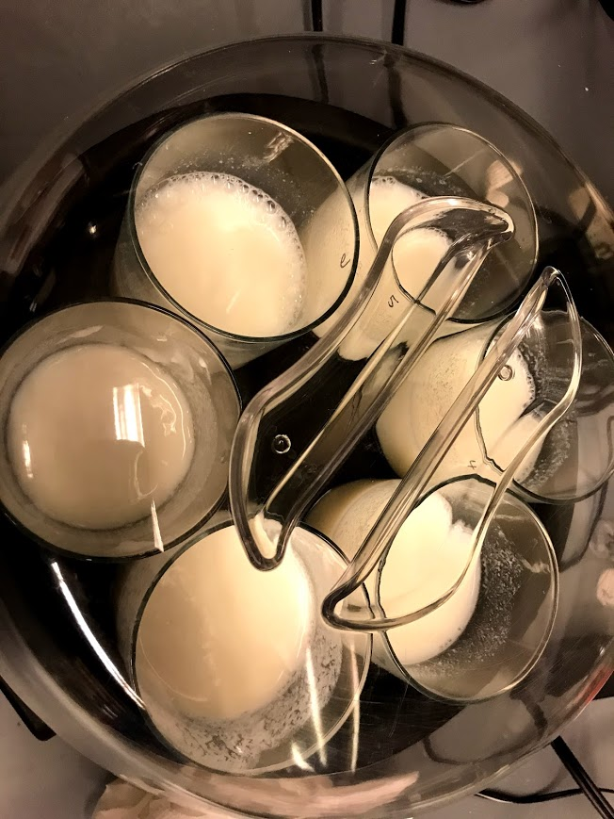

###### Figure 11: Yogurt Fermentation Image in Yogurt Maker

Figure 12 shows the graphical results of the two-hour lab-scale fermentation. Based on literature, expected results were that beakers around a pH of 5.5-4.8 would be decreasing in pH most quickly. In this lab experiment, beakers with higher starting pH had the largest drop in pH. One factor affecting the pH change was that the beakers were still heating up to steady state such that the cultures were behaving differently as temperature changed. Figure 13 shows the temperature during the fermentation.

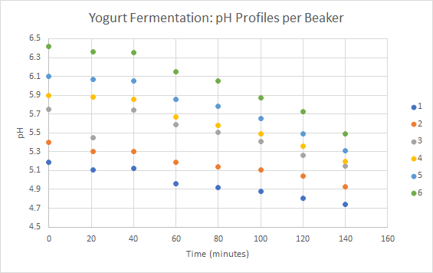

###### Figure 12: Beaker pH Profiles over Time

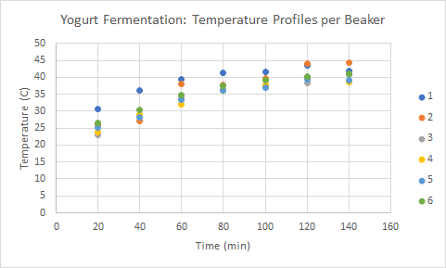

###### Figure 13: Beaker Temperature Profiles over Time

Power measurements were taken with a plug-in power meter, which showed the yogurt maker using either 0 or 36W at any given time. The yogurt maker likely operates with bang-bang control by turning on a heater when the temperature goes below range. 140J was the energy usage estimate for the 2-hour period, during which the clear plastic lid was removed several times for sampling and the beakers were still being heated to reach steady state. A fermentation without energy loss due to lid removal and where the beakers have reached steady state would use less energy.

### Drying

Spray drying equipment was unavailable for testing at this time, so an American Scientific Products Constant Temperature Oven Model DN-81 was used (Figure 14). The oven was heated to a temperature of 100oC and the yogurt, weighed and spread onto a baking sheet, was heated in the oven for thirty minutes. The yogurt was removed after ten minutes and re-weighed before being put back into the oven. From then on, the yogurt was removed and re-weighed every five minutes, then returned to the oven.

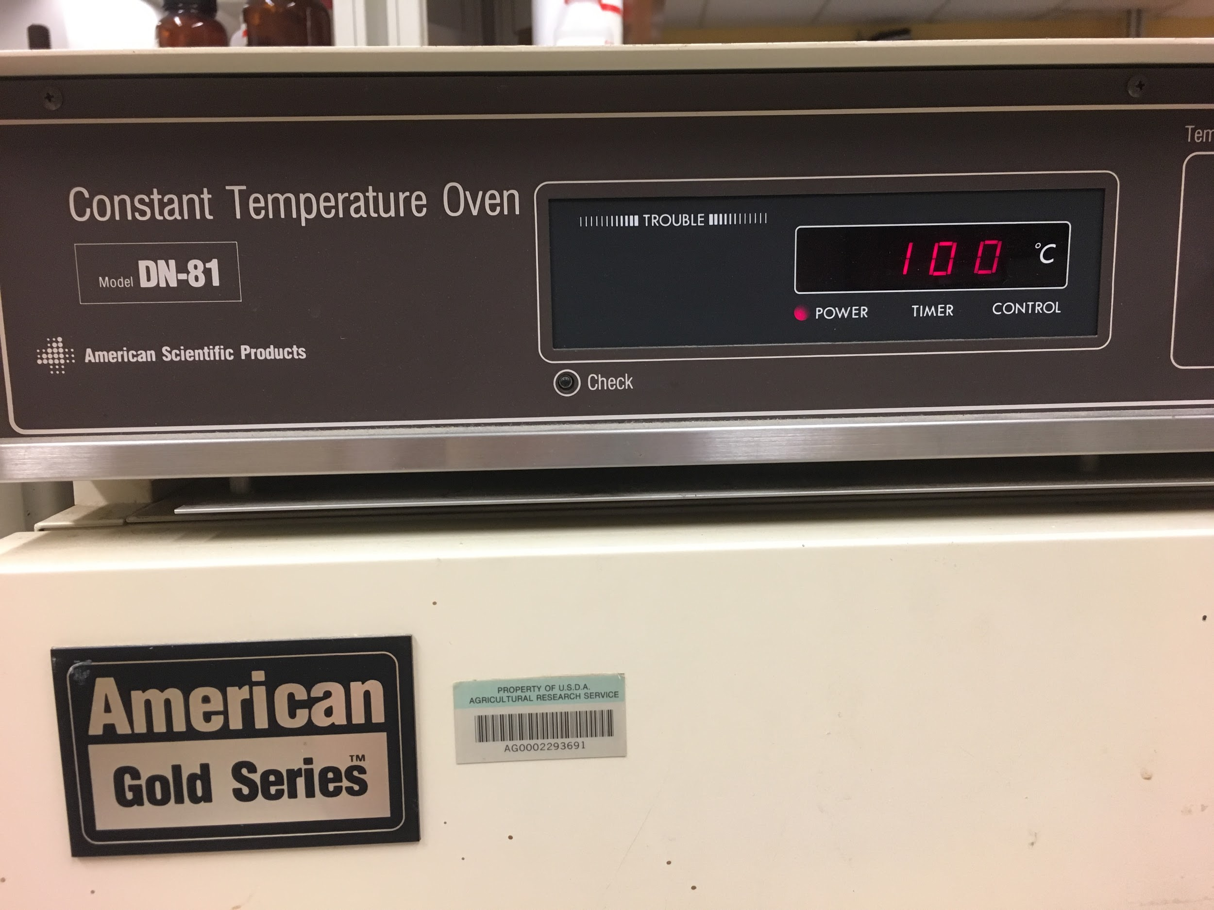

###### Figure 14: The constant temperature oven used for preliminary drying experimentation. The oven was set to 100oC and the yogurt was dried for thirty minutes

To find the original moisture content, the USDA database was searched to find the moisture content of typical Greek yogurt, 83%. This percentage was multiplied by the original mass of the yogurt found by zeroing the scale with the baking pan and then spreading the yogurt on the pan. The non-water mass was found and subtracted from the masses found at each measurement time to calculate the mass of water left after each time interval. The percent moisture content was calculated by dividing the water mass by the total mass. Moisture content was graphed over time in Figure 15.

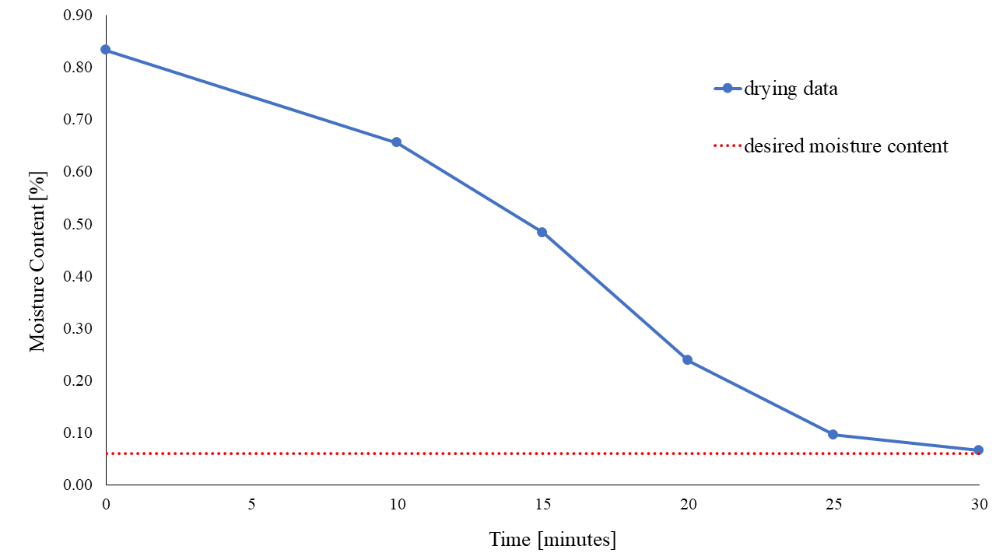

###### Figure 15: Results of drying experiment, moisture content [%] versus time [minutes]. After drying in the oven for thirty minutes, the yogurt lost enough water to reach the desired moisture content.

The yogurt was hard and crusty after the drying process as it had baked onto the pan. The comparison of the yogurt appearance before and after can be seen in Figure 16.

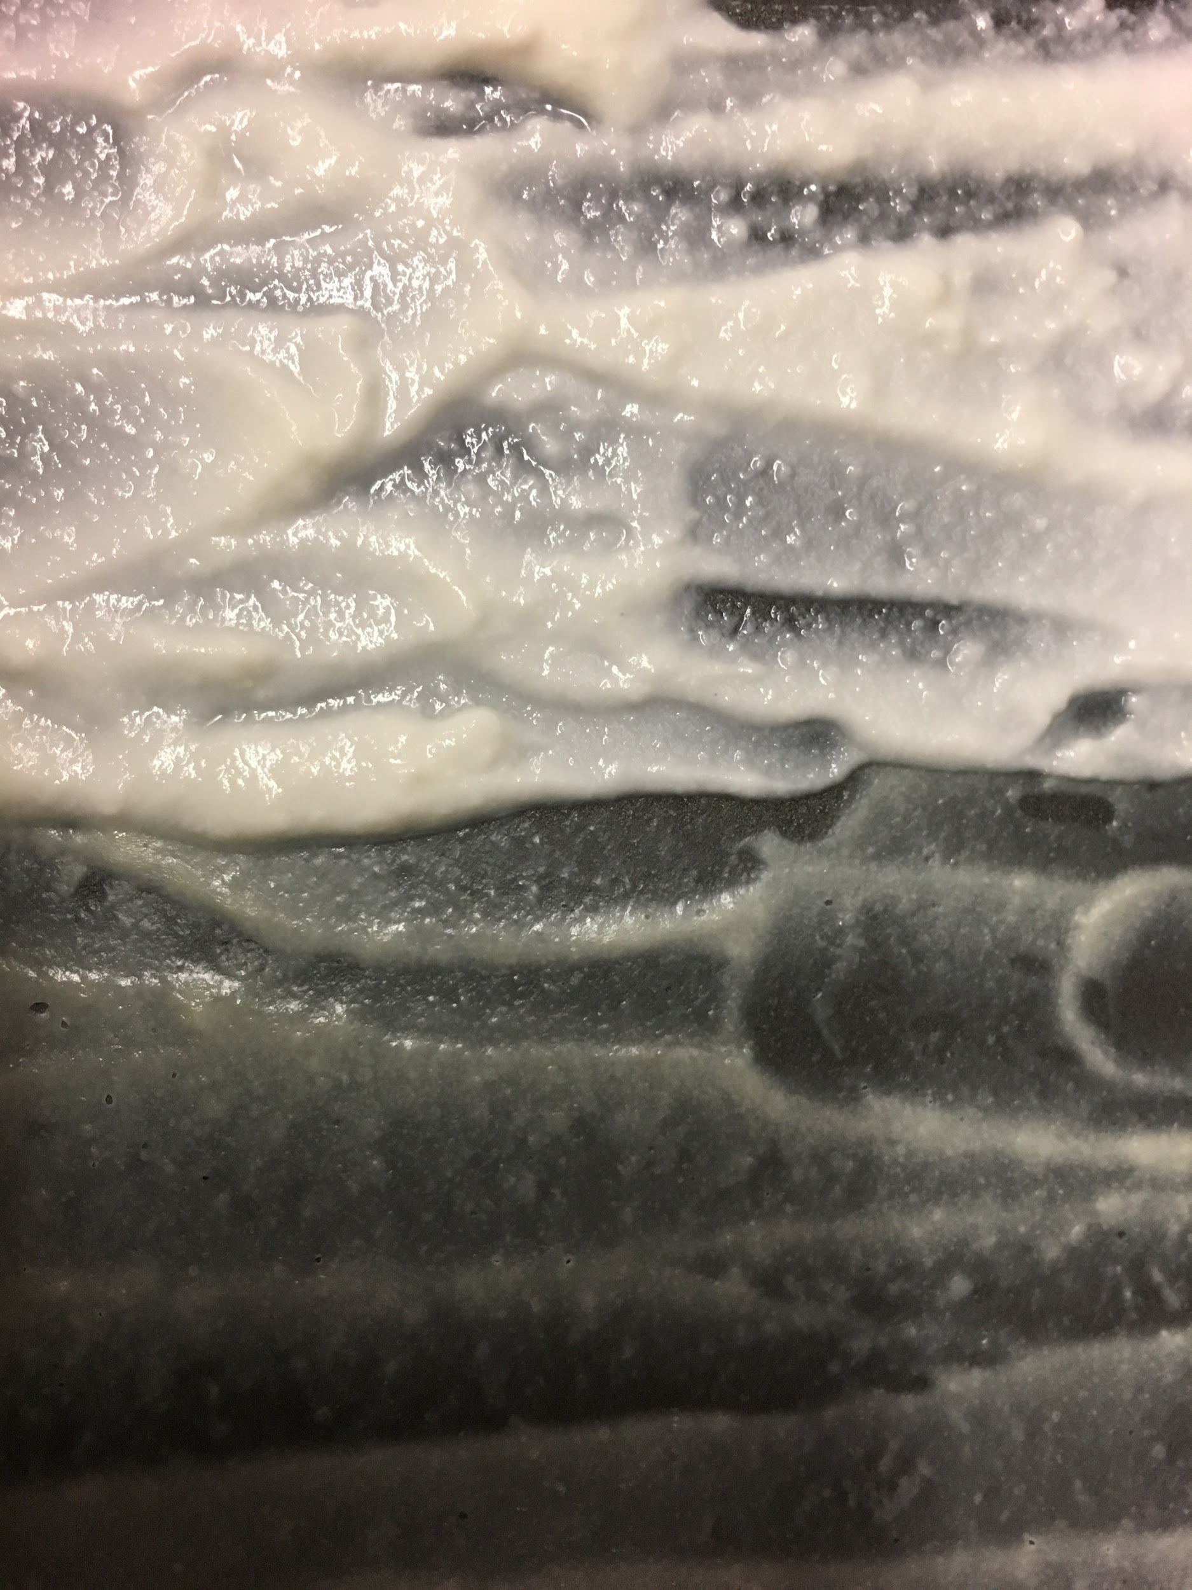

###### Figure 16: The yogurt before drying (left) and after drying for thirty minutes (right).

# Design Equations and Performance Curves

The designed pasteurization system is a continuous process that uses a plate heat exchanger to heat up the milk and then it is held in the holding tube. The area of the heat exchanger and the length of the holding tube are key parameters to design the sterilization system. The area of the heat exchanger can be calculated using an energy balance equation based on the heat generated by the heat exchanger and heating fluid. Once the area of the heat exchanger is found a flow rate through the pipe can be assumed based on an appropriate velocity. With a flow rate, a desired holding time of 20 seconds is used to calculate the length of the holding tube. The power requirement for each heat exchanger was also calculated. Sample calculations are shown in Appendix A. The primary variables for the heat exchanger design are shown in Table 3.

###### Table 3: Primary variables for pasteurization set-up

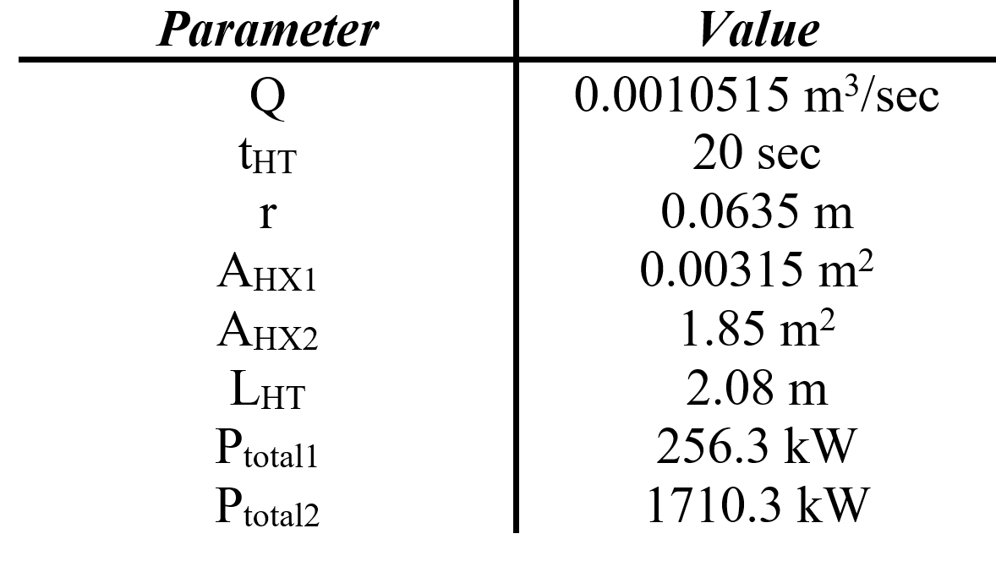

The theoretical performance of the heat exchanger will depend on the exit temperature of the milk stream as well as the mass flow rate the heating fluid. With an increase in mass flow rate there is an increase in the heat transfer coefficient inside the heat exchanger. This relationship can be shown in Figure 17.

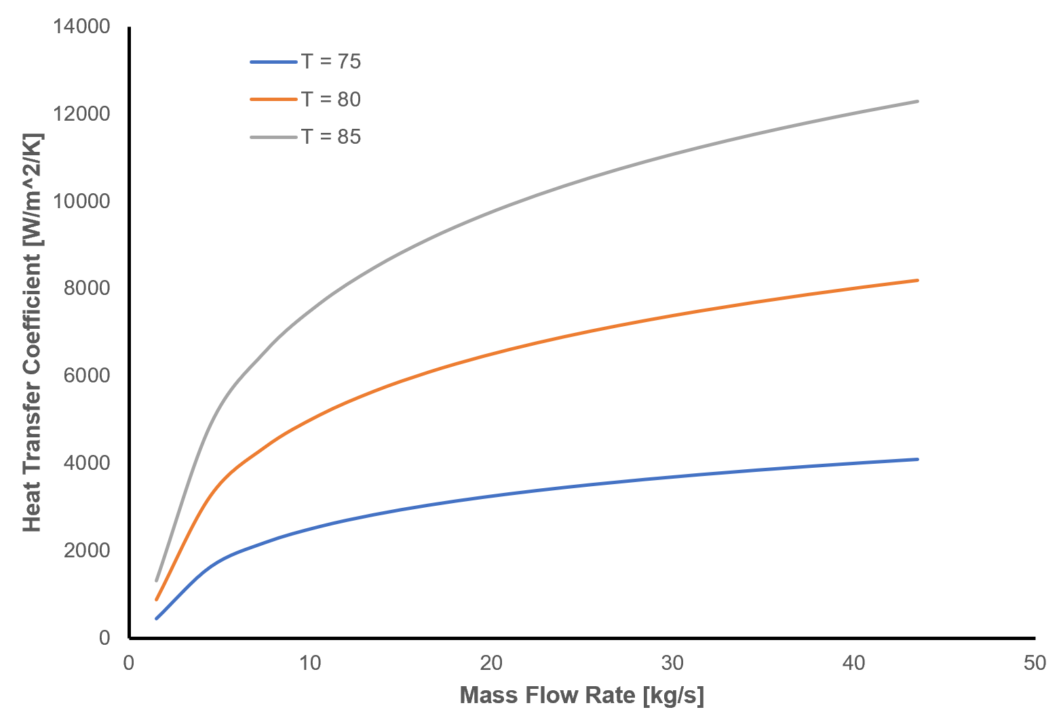

###### Figure 17: Heat transfer coefficient relationship between mass flow rate and exit stream temperature

## Concentration

Maintaining consistent filtration throughout the concentration process is dependent on a variety of factors, one of which is transmembrane pressure. Based on data from a variety of published milk microfiltration protein fractionation equipments, a hypothetical performance curve for variation in transmembrane pressure over time was developed. These results, depicted in Figure 18, compare pressure variation between membrane pore sizes. As pore size decreases, the pressure differential increases. Transmembrane pressure for microfiltration should remain around 0.5 bar. Additionally, this figure depicts the fouling process during filtration. Over time, sediment deposits on the filter prevent efficient passage and increase transmembrane pressure for all filtration processes.

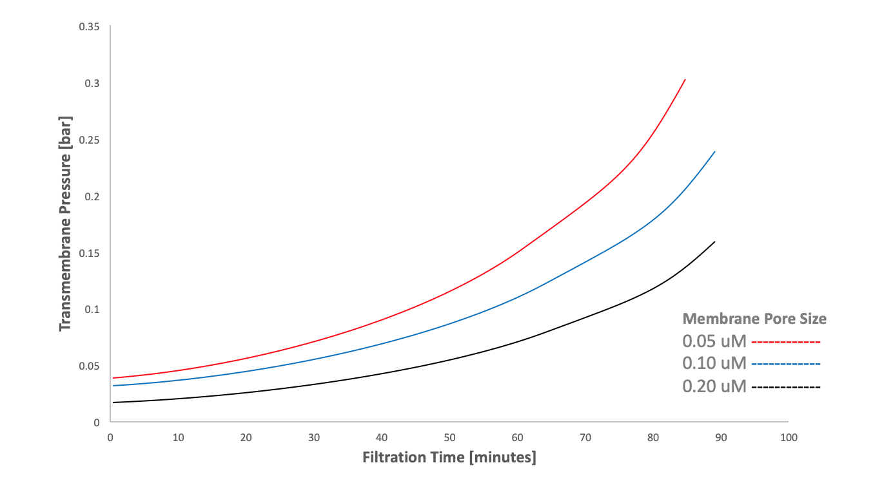

###### Figure 18: Hypothetical changing transmembrane pressure over time in microfiltration systems of varied pore size

In the future, experimentation will be tested by comparing the protein content of the inlet and outlet streams for the filtration process. The Kjeldahl Method will be used to compare the overall protein content of each stream. Since this microfiltration process is fractionating protein, the individual casein and whey contents of the streams will also be observed by comparing SDS-Page gels of each stream or using an alternative chromatography method.

## Fermentation

#### Performance Curve

Based on literature, the following performance curve, Figure 19, shows predicted lactic acid production over time with varied temperatures. This performance curve is essentially an average across several strains of bacteria of lactic-acid bacteria in milk.

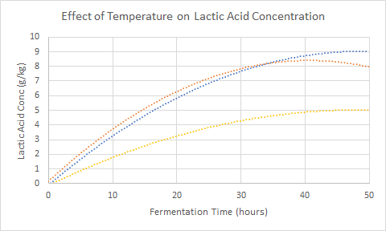

###### Figure 19: Effect of Temperature on Lactic Acid Fermentation over Time

#### Design Equations

Given a mass of 1713.6 kg per batch, the tanks are designed to be 2000L with a height: diameter ratio of 2:1. For the heat exchangers before and after fermentation, the area over which heat transfer occurs must be 0.098 m2 and 1.87 m2 respectively.

## Spray Drying

### Equipment Design

As the equipment will be processing the yogurt with 1505.35 kg of air per hour and the residence time of each particle in the dryer is about ten seconds, the volume of the dryer should be at least 204.73 m3.

1505.35 kg / hour * 1 hour / 60 seconds = 25.08 kg / second

25.08 kg / second * 10 seconds = 250.8 kg / residence

250.8 kg / residence* 1 m3 / 1.225 kg = 204.73 m3 / residence

The equipment should be as tall as reasonably possible (about 10 meters tall) to ensure maximum drying time and exposure to the hot air. If the diameter is assumed to be 5 meters across, then the height should be 10.43 m

204.73 m3 = π * r2 * h

204.73 m3 = π * 2.52 * h

65.17 m3 = 6.25 * h

10.43 m = h

### Theoretical Performance Curve

In addition to height and temperature, the air velocity is another variable that will need to be taken into consideration when designing the spray drying equipment. From the performance curve in Figure 20, it is most ideal to have a high air velocity to decrease the required residence time.

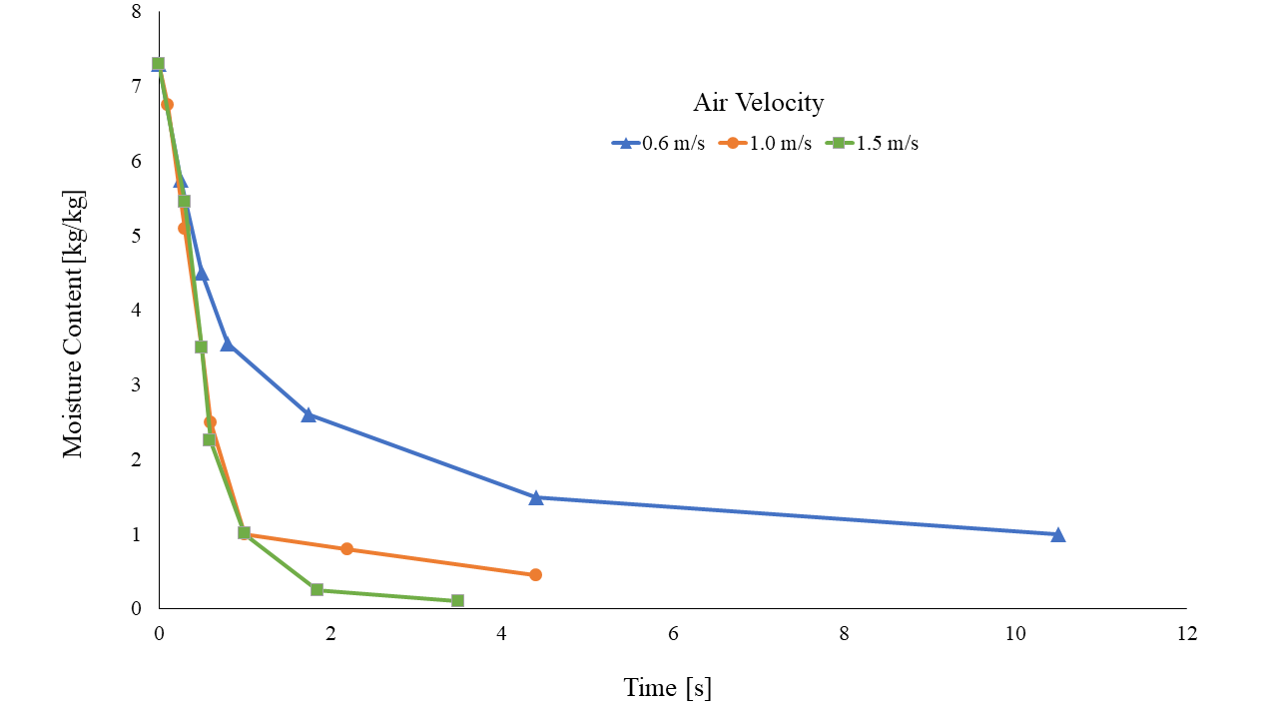

###### Figure 20: Spray dryer performance curve of moisture content versus residence time at different air velocities. The theoretical data shows that the product dries faster at a higher air velocity, which is ideal for the process to prevent overheating the product and killing the microbes.

# Conclusions and Future Directions

The yogurt market is open for a new form of eating yogurt. The amount of people that are interested in an alternative to spoonable yogurt is rising, and dehydrated greek yogurt addresses this trend. After discussing processing alternatives for key unit operations such as pasteurization, concentration, fermentation, and spray drying, methods for making dehydrated yogurt were designed and analyzed with mass and energy balances. Considering literature reporting the operation of all four unit operations, a reasonable and responsible dried yogurt process has been designed. The methods were then applied in lab to evaluate whether they achieved desired design parameters. A Plackett-Burman DOE was also created to see whether our process could be working more efficiently by testing the maximum and minimum values for each variable. In the future, these experiments will be run in a lab setting to solidify the methods used. From the lab scale, the process will be transferred to a pilot plant level where equipment designed using equations can be used and verified that the process runs properly. Testing final product sensory characteristics will be essential as well when evaluating the process capabilities of the pilot plant. After the methods have been sufficiently tested, a plant can be designed with the necessary throughput to bring to market.

# Appendix A: Data & Calculations

## Sterilization

### Regenerative Heating Energy Balance Equation

mmilk * cp,milk * dTmilk,raw = mmilk * cp,milk * dTmilk,sterilized

mmilk = 500kg

cp,milk = 3.95 kJ/kg/K (Geankoplis, 2003)

Tmilk,raw = 4 C

Tmilk,preheat = ?

dTmilk,raw = 4C - Tmilk,preheat

Tmilk,sterilized = 80 C

Tmilk,cooled = 50 C

dTmilk,sterilized = 50 C - 80 C = -30 C = -30 K

**Tmilk,preheat = 34 C**

mfrmilk = 0.139 kg/s

dTavg = [(Tmilk,cooled - Tmilk,raw) + (Tmilk,sterilized - Tmilk,preheat)]/2

dTavg = [(50 - 4)+(80 - 34)]/2 = 46 K

U = 267 W/m2K (Geankoplis, 2003)

dTsterilized,milk = 80 - 50 = 30 K

**AHX = 0.00315 m2**

### Pasteurization Energy Balance

mmilk * cp,milk * dTmilk = msteam * cp,steam * dTsteam

mmilk = 500kg

cp,milk = 3.95 kJ/kg/K

Tmilk,preheat = 34 C

Tmilk,sterilized = 80 C

dTmilk = 34 - 80 = -46 K

cp,steam = 1.926 (Geankoplis, 2003)

Tsteami = 200 C

Tsteamo = 180 C

dTsteam = 20 K

Solving for msteam

msteam = 2358.5 kg to heat the preheat milk to the sterilized milk temperature

Assuming 1 minute to heat up 500 kg of milk **mfrsteam = 39.3 kg/s**

U = 267 W/m2K (Geankoplis, 2003)

dTavg = [(Tsteamf - Tmilk,preheat) + (Tsteami - Tmilk,sterilized)]/2

dTavg = [(180 - 34) + (200 - 85)]/2 = 130.5 K

dTsteam = 200 - 180 = 20 K

AHX = 1.85 m2

### Holding Tube Length

Q = 0.0010515 m3/sec

r = 0.0635 m

tHT = 20 sec

LHT = Q * tHT / π / r2

**LHT = 1.66 meters**

### Heat Exchanger Power

#### First Heat Exchanger

dThot = 80 C - 50 C = 30 C

dTcold = 34 C - 4 C = 30 C

Q = 3.78 m3/h * 1030 kg/m3 (density of milk according to Douglas Goff. University)

= 3893.4 kg/h

cp,milk = 1.0972e-3 kWh/kg/K

Phot = Q * cp,milk * dThot

Pcold = Q * cp,milk * dTcold

Phot = 128.2 kW

Pcold = 128.2 kW

Ptotal = Phot + Pcold = 256.3 kW

**Ptotal = 256.3 kW**

#### Second Heat Exchanger

dThot = 200 C - 180 C = 20 C

dTcold = 80 C - 34 C = 46 C

Qcold = 3893.4 kg/hr

Qhot = 141480 kg/hr

cp,milk = 1.0972e-3 kWh/kg/K

cp,steam = 5.35e-4 kWh/kg/K

Phot = Qhot * cp,steam * dThot

Pcold = Qcold * cp,milk * dTcold

Phot = 1513.8 kW

Pcold = 196.5 kW

Ptotal = Phot + Pcold

**Ptotal = 1710.3 kW**

## Fermentation

###### Table 4: Lab-Scale Yogurt Fermentation Raw Data

|  |  |  |  |  |  |  |
| --- | --- | --- | --- | --- | --- | --- |
| **Beaker** | **1** | **2** | **3** | **4** | **5** | **6** |
| **initial pH** | 5.19 | 5.4 | 5.75 | 5.9 | 6.1 | 6.42 |
| **20 minutes pH** | 5.11 | 5.3 | 5.45 | 5.88 | 6.07 | 6.36 |
| **20 minutes T** | 30.6 | 26.1 | 23 | 23.7 | 25.2 | 26.6 |
| **40 minutes pH** | 5.12 | 5.3 | 5.74 | 5.86 | 6.05 | 6.35 |
| **40 minutes T** | 36.2 | 27.2 | 28.7 | 29.1 | 28.2 | 30.3 |
| **60 minutes pH** | 4.96 | 5.19 | 5.59 | 5.67 | 5.86 | 6.15 |
| **60 minutes T** | 39.5 | 38 | 34 | 32 | 33.3 | 34.8 |
| **80 minutes pH** | 4.92 | 5.14 | 5.51 | 5.58 | 5.78 | 6.05 |
| **80 minutes T** | 41.3 | 37.9 | 36.5 | 36 | 36.1 | 37.6 |
| **100 minutes pH** | 4.88 | 5.11 | 5.41 | 5.49 | 5.65 | 5.87 |
| **100 minutes T** | 41.6 | 39.6 | 37.3 | 37.7 | 37 | 39.2 |
| **120 minutes pH** | 4.81 | 5.04 | 5.26 | 5.36 | 5.49 | 5.73 |
| **120 minutes T** | 43.4 | 44 | 38.3 | 40 | 39.5 | 40.3 |
| **140 minutes pH** | 4.74 | 4.93 | 5.15 | 5.2 | 5.31 | 5.49 |
| **140 minutes T** | 41.9 | 44.4 | 40.9 | 38.7 | 39.1 | 41.1 |

## Drying

### Energy Balance on Air

1505.35 kg * 1.013 kJ/kg.K * (60.5C - 171C)

= 1505.35 kg * 1.013 kJ/kg.K * -110.5 K

= 1505.35 kg * -111.9365 kJ/kg

= -168503.61 kJ

### Energy Balance on Yogurt

#### Choi Okos Equation

* Water = 4.1855 kJ/kg.K * 2.81 kg water = 11.76 kJ / K
* Proteins = (2.0082 × 103 + 1.2089(15) – 1.3129 × 10-3(15)2 J / kg.K) * (21.9 kg) = (2008.2 + 18.1335 - 0.2954) * 21.9 = 2026.04 * 21.9 = 44370.23 J/K = 44.37 kJ/K
* Fats = (1.9842 × 103 + 1.4733(15) – 4.8008 × 10-3(15)2 J/kg.K) * (0.7 kg) = (1984.2 + 22.1 - 1.08) * 0.7 = 2005.22 * 0.7 = 140.37 J/K = 0.140 kJ/K
* Carbohydrates = (1.5488 × 103 + 1.9625(15) – 5.9399 × 10-3(15)2 J/kg.K) * (10.8 kg) = (1548.8 + 29.44 - 1.34) * 10.8 = 1576.9 * 10.8 = 17030 J/K = 17.03 kJ/K
* Ash = (1.0926 × 103 + 1.8896(15) – 3.6817 × 10-3(15)2 J/kg.K) * 5.2 kg = (1092.6 + 28.34 - 0.828) * 5.2 = 1120 * 5.2 = 5824 J/K = 5.824 kJ/K
* Total = 11.76 kJ / K + 44.37 kJ/K + 0.140 kJ/K + 17.03 kJ/K + 5.824 kJ/K = 79.124 kJ/K

168503.61 kJ = (236.19 kg * 581 kJ/kg) + (236.19 kg * 1.8644 kJ/kg*K * (60.5C - 15oC)) + (79.124 kJ/K * (Temperature of Yogurt Out - 15C))

168503.61 kJ = 483103 kJ + 33246.43 kJ + (79.124 kJ/K * (Temperature of Yogurt Out - 15oC))

168503.61 kJ = 137234.67 kJ + 33246.43 kJ + (79.124 kJ/K * (Temperature of Yogurt Out - 15oC))

# Appendix B: Super Pro Analysis

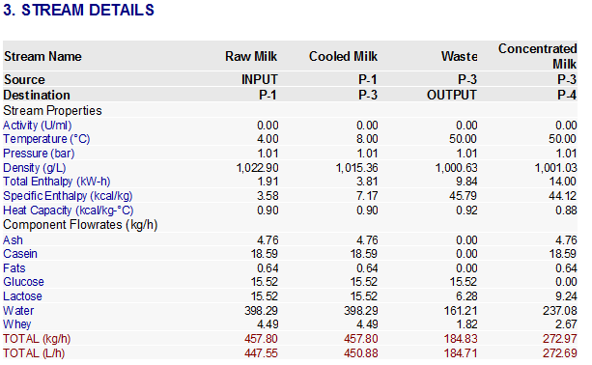

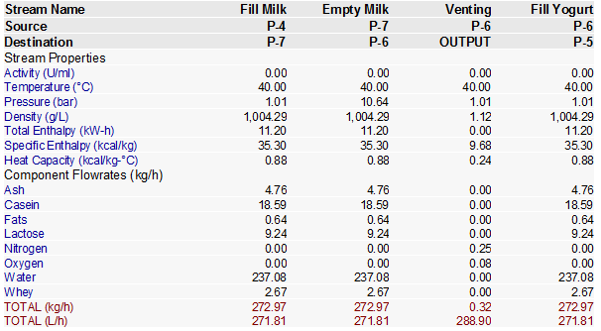

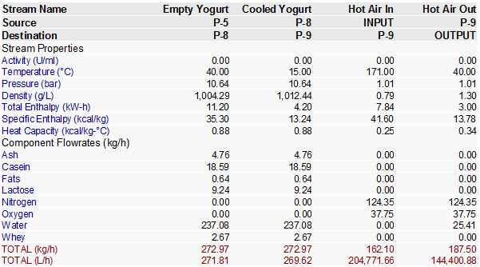

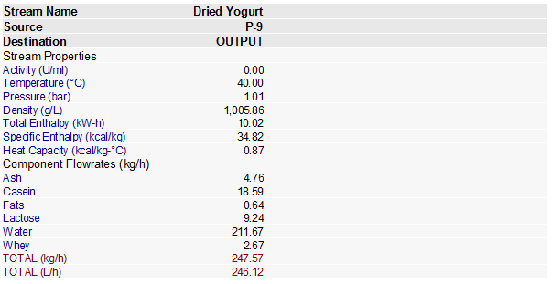

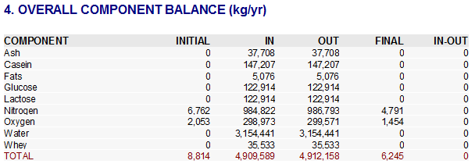

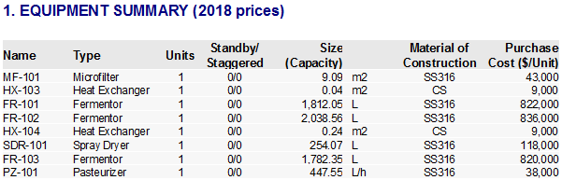

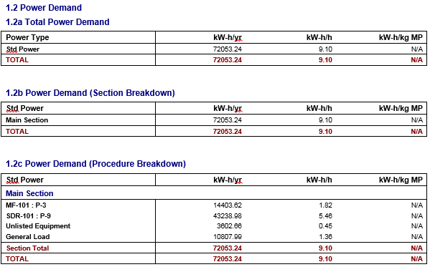

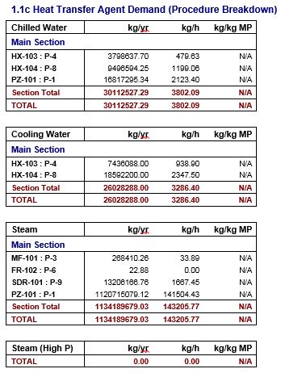

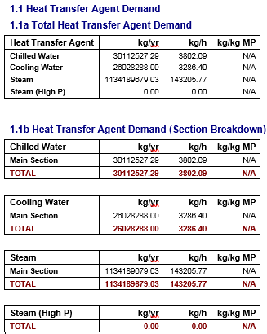

Differences between hand calculations and SuperPro’s mass balance calculations occurred due to restrictions on certain unit operation properties that SuperPro did not allow the user to alter. For example, in the fermentation process, the SuperPro software did not allow the inclusion of the intermediate step of breaking glucose into lactose and galactose which altered the mass balance of the operation. Additionally, the hand calculation for energy balance within the concentration unit operation used a mass percent retention method, while SuperPro software required the use of retention coefficients that differed slightly from the previous values. Finally, in order to ensure that the continuous timing worked within the SuperPro software, the program required the auto-adjustment of the input mass flow rates.

Additionally, there were variations between the energy balance calculations determined by hand and via the superpro software. The energy requirements for the individual units were calculated by hand, focusing on equipment cross-sectional area and temperature variations over an hourly time frame. The superpro software compiled energy data as one continuous process, outputting input steam and power information for a large-scale operation with daily and yearly requirements. The software added additional details about the heat transfer input streams, and it restricted user ability to adjust certain temperature requirements within the unit operations. For example, the regeneration temperature of the pasteurization process was not adjustable, and this altered the energy balance for the entire pasteurization process.

# 

# Appendix C: References

(2018). New and Replacement Filters for Microfiltration Systems. *Porex Filtration Group*.

Adolfsson, Oskar. "Yogurt and Gut Function." *The American Journal of Clinical Nutrition*, vol. 80, no. 2, 1 Aug. 2004, pp. 245-56, doi:10.1093/ajcn/80.2.245. Accessed 17 Sept. 2018.

Aguiar, H.F., Gut, J. (2014). Continuous HTST pasteurization of liquid foods with plate heat exchangers: Mathematical modeling and experimental validation using a time-temperature integrator. *Journal of Food Engineering*, 123(1), 78-86.

Ahmed, J., & Rahman, S. (2012). Handbook of Food Process Design, 1078-1106, Hoboken,

United States of America: Wiley-Blackwell.

Allgeyer, L C, et al. "Sensory and microbiological quality of yogurt drinks with prebiotics and probiotics." *Journal of Dairy Science*, vol. 93, no. 10, Oct. 2010, pp. 4471-79, doi:10.3168/jds.2009-2582. Accessed 15 Sept. 2018.

Amirdivani, Shabboo[BAM1] , and Ahmad Salihin Baba. (2011). “Changes in Yogurt Fermentation Characteristics, and Antioxidant Potential and in Vitro Inhibition of Angiotensin-1 Converting Enzyme upon the Inclusion of Peppermint, Dill and Basil.” *LWT - Food Science and Technology*, vol. 44, no. 6, pp. 1458–1464., doi:10.1016/j.lwt.2011.01.019.

Anonymous. (2005, February). Perfect powders. *Dairy Industries International,* 70(2), 1-9. Retrieved October 3, 2018

Arunkumar, Abhiram and Etzel, Mark R. “Milk Protein Concentration Using Negatively Charged Ultrafiltration Membranes.” Foods (2018).

Barbosa-Canovas, G. V., & Bermúdez-Aguirre, D. (2008). Introduction. Food Science and Technology International, 14(5), 403–409

Bautista, E. S., Dahiya, R. S., & Speck, M. L. (1966). Identification of compounds causing symbiotic growth of Streptococcus thermophilus and Lactobacillus bulgaricus in milk*. *Journal of Dairy Research, 33*(03), 299. doi:10.1017/s0022029900011985.

Biliaderis, C.G., Khan, M. M., & Blank, G. “Rheological and Sensory Properties of Yogurt from Skim Milk and Ultrafiltered Retentates.” International Dairy Journal 2 (1992): 311-323.

Bong, D.D. and Moraru, C.I. “Use of micellar casein concentrate for Greek-style yogurt manufacturing: Effects on processing and product properties.” Journal of Dairy Science. 97.3 (2014) 12590-1269.

Brighenti, M. “Effects of processing conditions on the texture and rheological properties of model acid gels and cream cheese.” Journal of Dairy Science. 101.8 (2018): 6762-6775.

Bogahawaththa, D., Buckow, R., Chandrapala, J., & Vasiljevic, T. (2018). Comparison between thermal pasteurization and high pressure processing of bovine skim milk in relation to denaturation and immunogenicity of native milk proteins. Innovative Food Science & Emerging Technologies, 47, 301–308

Burrington, K.J. Milk Fractionation Technology and Emerging Milk Protein Opportunities.

*Dairy Research Institute-Technical Report.*

Bylund, G. (1995). Dairy Processing Handbook. Lund, Sweden: Tetra Pak. Processing Systems AB.

Cajigas, Stanley. Instant Yogurt Composition and Process. US005145697A, US Patent and Trademark Office, 8 September 1992.

Centers for Disease Control and Prevention. (2017, September 1). Raw Milk Questions and Answers. Retrieved October 12, 2018

Chai, Milton et al. “Separation and concentration of milk proteins with submerged membrane vibrational system.” Journal of Membrane Science 524 (2017) 305-314.

Chandan, Ramesh C. “An Overview of Yogurt Production and Composition.” Yogurt in Health and Disease Prevention. Chapter 2. (2017) 42-44.

Chandrapala, Jayani. “Strategies for Maximizing Removal of Lactic Acid from Acid Whey – Addressing the un-processability issue.” Separation and Purification Technology 172 (2017): 489-497.

Chandrapala, Jayani. “Properties of acid whey as a function of pH and temperature.” Journal of Dairy Science. 98.07 (2017): 4352-4363.

Conte, C. et al. “Different Alternatives to Improve Rheological and Textural Characteristics of Fermented Goat Products – A Review.” Rheology: Open Access. 1.1 (2017). 1-6.

Chandan, R., White, C., Kilara, A., Hui, Y. (2006). *Manufacturing Yogurt and Fermented Milks*. Ames, IA: Blackwell Publishing.

Chuayana Jr, Eduardo L., et al. "Antimicrobial activity of probiotics from milk products." *Phil J. Microbiol. Infect. Dis*32.2 (2003): 71-74.

Dibyakanta, S., Dash, K. K., Mishra, H. N., & Deka, S. C. (2018, October). Thermodynamics of sorption isotherms and storage stability of spray dried sweetened yoghurt powder. *Journal of Food Science and Technology,* 55(10), 4139-4147. doi:10.1007/s13197-018-3340-6

Dairy Processing Handbook. 6.2 (1995).

Driessen, F. M., Ubbels, J., & Stadhouders, J. (1977a). Continuous manufacture of yogurt. I. Optimal conditions and kinetics of the pre-fermentation process. *Biotechnology and Bioengineering,19*(6), 821-839. doi:10.1002/bit.260190604.

Driessen, F. M., Ubbels, J., & Stadhouders, J. (1977b). Continuous manufacture of yogurt. II. Procedure and apparatus for continuous coagulation. *Biotechnology and Bioengineering,19*(6), 841-851. doi:10.1002/bit.260190605.

Daufin, G. et al. “Recent and Emerging Applications of Membrane Processes in the Food and Dairy Industry.” Trans IChemE 79.C (2001).

Farkye, Nana. “Quark, Quark-like Products, and Concentrated Yogurts.” Cheese: Chemistry, Physics, and Microbiology. Chapter 43 (2017).

“Food Facts: How Much Water Does It Take to Produce?” *Water Education Foundation*. N.d. Accessed 16 Sept. 2018.

Floris, P., Curtin, S., Kaisermayer, C., Lindeberg, A., & Bones, J. (2018). Development of a versatile high-temperature short-time (HTST) pasteurization device for small-scale processing of cell culture medium formulations. *Applied Microbiology and Biotechnology, 102(13),* 5495–5504

Geankoplis, C.J. (2003). *Transport Processes and Separation Process Principles*. Upper Saddle River, NJ Prentice Hall.

Gerdes, S. (2009, October). Exploring Yogurt Powder. *Dairy Foods*, 110(10), 88-90. Retrieved October 3, 2018

Gyawali, R. and Ibrahim, S. A. “Effects of hydrocolloids and processing conditions on acid whey production with reference to Greek yogurt.” Trends in Food Science and Technology 56 (2016) 61-76.

Gyawali, R. and Ibrahim, S.A. “Addition of pectin and whey protein concentrate minimizes the generation of acid whey in greek-style yogurt.” Journal of Dairy research 85 (2018): 238-242.

Glover, F.A. (1984). Principles of Ultrafiltration and the Concentration and Fractionation of Cow’s Milk. *Human Milk Banking, Nestle.* 1-16.

Grant, I. R., Ball, H. J., & Rowe, M. T. (1999). Effect of higher pasteurization temperatures, and longer holding times at 72oC, on the inactivation of Mycobacterium paratuberculosis in milk. Letters in Applied Microbiology, 28(6), 461–465

Ibrahim, S.A. et al. “Rheological Properties of Set Yogurt as Influenced by Incubation temperature and Homogenization.” Journal of Food Quality 25 (2002) 409-418.

International Dairy Foods Association. (n.d.). Pasteurization. Retrieved October 12, 2018

Jess, S.J., Roberts, R.F., and Ziegler, G.R. “Rheological Properties of Nonfat Yogurt Stabilized Using Lactobacillus delbrueckii ssp. Bulgaricus Producing Exopolysaccharide or Using Commercial Stabilizer Systems.” Journal of Dairy Science 80 (1997): 252-263.

Jo, Y., Benoist, D., Barbano, D., & Drake, M. (2018). Flavor and flavor chemistry differences among milks processed by high-temperature, short-time pasteurization or ultra-pasteurization. Journal of Dairy Science, 101(5), 3812–3828

Kailasapathy, K. (2006). Survival of free and encapsulated probiotic bacteria and their effect on the sensory properties of yoghurt. *LWT - Food Science and Technology, 39*(10), 1221-1227. doi:10.1016/j.lwt.2005.07.013.

Kim, Suk S., and Santi R. Bhowmik. "Survival of Lactic Acid Bacteria during Spray Drying of Plain Yogurt." *Journal of Food Science*, vol. 55, no. 4, July 1990, pp. 1008-10.

Kim, S. S., & Bhowmik, S. R. (1994). Moisture Sorption Isotherms of Concentrated Yogurt and Microwave Vacuum Dried Yogurt Powder. *Journal of Food Engineering*, 21(2), 157-175. Retrieved October 2018, 2018

Koc, B., Sakin-yilmazer, M., Kaymak-ertekin, F., & Balkir, P. (2014, July). Physical properties of yoghurt powder produced by spray drying. Journal of Food Science and Technology, 51(7), 1377-1383. doi:10.1007/s13197-012-0653-8

Koc, B., Yilmazer, M.S., Balkir, P., Ertekin, F.K. (2010). Spray Drying of Yogurt: Optimization of Process Conditions for Improving Viability and Other Quality Attributes. *Drying Technology: An International Journal.* **28**(4), 495-507.

Koutchma, T. (2014). *Adapting High Hydrostatic Pressure (HPP) for Food Processing Operations*. Amsterdam, Netherlands: Elsevier Science.

Krzeminski, A., Grobhable, K., and Hinrichs, J. “Structural properties of stirred yoghurt as influenced by whey proteins.” LWT – Food Science and Technology 44 (2011) 2134-2140.

Labropolous, A. E., Lopez, A., & Baker, J. L. (1981). A Computerized Procedure for Estimating Chemical Changes in Thermal Process Systems. Journal of Food Science, 46(6), 1976–1977

Laureati, M et al. "Sustainability and organic production: How information influences consumer’s expectation and preference for yogurt." *Food Quality and Preference*, vol. 30, no. 1, Oct. 2013, pp. 1-8. Accessed 17 Sept. 2018.

Linton, M., Patterson, M. F., & Patterson, M. F. (2000). High pressure processing of foods for microbiological safety and quality. Acta Microbiologica et Immunologica Hungarica, 47(2-3), 175–182.

Le, T. et al. Membrane Separations in Dairy Processing (Review).” 2.1 (2014) 01-14.

Lucey, John A. “The relationship between rheological parameters and whey separation in milk gels.” Food Hydrocolloids. 15.4-6 (2001): 603-608

Lu, G., Li, C., & Liu, P. (2011). UV inactivation of milk-related microorganisms with a novel electrodeless lamp apparatus. European Food Research and Technology, 233(1), 79–87.

Macbean, R. D., Hall, R. J., & Linklater, P. M. (1979). Analysis of pH-stat continuous cultivation and the stability of the mixed fermentation in continuous yogurt production. *Biotechnology and Bioengineering,21*(9), 1517-1541. doi:10.1002/bit.260210903.

Modler, H., & Kalab, M. (1983). Microstructure of Yogurt Stabilized with Milk Proteins. *Journal of Dairy Science, 66*(3), 430-437. doi:10.3168/jds.s0022-0302(83)81810-4.

Merin, U and Daufin, G. (1990). Crossflow microfiltration in the dairy industry: state-of-the-art. *Lait* 70, 281-291.

Mintel Group Ltd. “Yogurt and Yogurt Drinks, US, August 2017” *Mintel Academic,* August 2017. Accessed 14 Sept. 2018.

Mistry, V. V. and Hassan, H. N. “Manufacture of Nonfat Yogurt from a High Milk Protein Powder.” Journal of Dairy Science 75: 947-957.

Montoro-Moreno, Miriam et al. “Ultrafiltration of skimmed goat milk increases its nutritional value by concentrating nonfat solids such as proteins, Ca, P, Mg, and Zn.” Journal of Dairy Science 98.11 (2015): 7628-7634.

Newkey-Burden, C. “Dairy is scary. The public is waking up to the darkest part of farming.” *The Guardian*. March 30, 2017. Accessed 16 Sept. 2018.

Okos, M. (2018, October 3). *Drying Equipment*. Retrieved from Blackboard Learn: ABE 557 Course Content: https://mycourses.purdue.edu/bbcswebdav/pid-11904509-dt-content-rid-88656569_1/courses/wl_21632.201910/DryingEquipmentDOC010611.pdf

Okos, M., Campanella, O., Narsimhan, G., Singh, R. K., & Weitnauer, A. C. (2007). Food Dehydration. In D. R. Heldman, D. B. Lund, & C. Sabliov, *Handbook of Food Engineering* (3rd ed., pp. 603-744). Milton Park, Oxfordshire, United Kingdom: Taylor and Francis Group, LLC. Retrieved October 3, 2018

Østlie, H. M., Treimo, J., & Narvhus, J. A. (2005). Effect of temperature on growth and metabolism of probiotic bacteria in milk. *International Dairy Journal,15*(10), 989-997. doi:10.1016/j.idairyj.2004.08.015.

Pouliot, Y. et al. “Effect of Ultrafiltration of Milk Prior to Fermentation on Mass Balance and Process Efficiency in Greek-Style Yogurt Manufacture.” Food. 7.144 (2018): 1-10.

Qureshi, A. M., et al. (2011). PREPARATION AND NUTRITIONAL EVALUATION OF GARLIC BASED YOGURT. *Science International*. Retrieved October 11, 2018.

Qi, P. X., Ren, D., Xiao, Y., & Tomasula, P. M. (2015). Effect of homogenization and pasteurization on the structure and stability of whey protein in milk. *Journal of Dairy Science*, 98(5), 2884–2897

Qin, Z., Chen, Q. et al. “The Application of Membrane Separation Technology in the Dairy Industry.” Technological Approaches or Novel Applications in Dairy Processing. Chapter 2. (2018): 22 - 34.

Rascon-Diaz, M. P., Tejero, J. M., Mendoza-Garcia, P. G., Garcia, H. S., & Salgado-Cervantes, M. A. (2012, February). Spray Drying Yogurt Incorporating Hydrocolloids: Structural Analysis, Acetaldehyde Content, Viable Bacteria, and Rheological Properties. *Food and Bioprocess Technology*, 5(2), 560-567. doi:10.1007/s11947-009-0312-x

Sandine, W.E., and P.R. Elliker. (1970). “Microbially Induced Flavors and Fermented Foods Flavor in Fermented Dairy Products.” *Journal of Agricultural and Food Chemistry*, vol. 18, no. 4, pp. 557–562., doi:10.1021/jf60170a023.

Sakin-yilmazer, M., Dirim, S. N., Di Pinto, D., & Kaymak-ertekin, F. (2014, December). Yoghurt with candied chestnut: freeze drying, physical, and rheological behavior. *Journal of Food Science and Technology,* 51(12), 3949-3955. doi:10.1007/s13197-012-0890-x

Scaman, C. H., Durance, T. D., Drummond, L., & Sun, D.-W. (2014). Combined Microwave Vacuum Drying. In D.-W. Sun, & D.-W. Sun (Ed.), *Emerging Technologies for Food Processing* (2nd ed., pp. 427-445). Cambridge, Massachusetts, United States: Academic Press. doi:https://doi.org/10.1016/B978-0-12-411479-1.00023-1

Scrimshaw, N S., and E B. Murray. "The acceptability of milk and milk products in populations with a high prevalence of lactose intolerance." *The American Journal of Clinical Nutrition*, vol. 48, no. 4, 1 Oct. 1988, pp. 1142-59. Accessed 17 Sept. 2018.

Sengupta, S., & Bhowal, J. (2017, February/March). EFFECTS OF DIFFERENT METHODS OF DRYING ON ANTIOXIDANT AND MICROSCOPIC CHARACTERISTICS OF Spirulina platensis ENRICHED SOY YOGURT. *The Journal of Microbiology, Biotechnology and Food Sciences*, 6(4), 1001-1006. doi:10.15414/jmbfs.2017.6.4.1001-1006

Serra, M, et al. "Acid coagulation properties and suitability for yogurt production of cows’ milk treated by high-pressure homogenization." *International Dairy Journal*, vol. 17, no. 7, July 2007, pp. 782-90. Accessed 14 Sept. 2018.

“Sustainable Agriculture: Dairy.” *World Wildlife Foundation*. November 17, 2015. Accessed 16 Sept. 2018.

Tamine, A.Y., Lalab, M., and Davies, G. “The effect of processing temperatures on the microstructure and firmness of Labneh made from cow’s milk by the traditional method or by ultrafiltration.” Food Structure 10 (1991): 345-352.

Tontul, I., Ergin, F., Eroglu, E., Kucukcetin, A., & Topuz, A. (2018, October). Physical and microbiological properties of yoghurt powder produced by refractance window drying. *International Dairy Journal*, 85, 169-176. doi:10.1016/j.idairyj.2018.06.002

Uduwerella, Gangani, Chandrapala, Jayani, and Vasiljevic, Todor. “Preconcentration of yoghurt base by ultrafiltration for reduction in acid whey generation during greek yoghurt manufacture.” International Journal of Dairy Technology. (2017)

“United States Yogurt Market and Yogurt Innovation Report 2018 - Market to Reach $9.8 Billion by 2022”. *Research and Markets*. June 13, 2018. Accessed 17 Sept. 2018

Varan, Cyrus O. Method and Apparatus for Dehydration of Yogurt during Transportation and Storage. US005356638A, US Patent and Trademark Office, 18 October 1994.

Yilmaz, M. T., Sert, D., & Karakaya, M. (2010, April). The effect of interaction on the functional properties of dairy powder solutions. *Australian Journal of Dairy Technology*, 65(1), 15-22. Retrieved October 3, 2018

“Yogurt”. *The Nutrition Source*. May 30, 2018. Accessed 17 Sept. 2018

Xu, Z.M. et al. “Effects of heating temperature and fat content on the structure development of set yogurt.” Journal of Food Engineering 85 (2008): 690-597.

Zhu, Yunwo, et al. "Competition between yogurt probiotics and periodontal pathogens in vitro." *Acta Odontologica Scandinavica*, vol. 68, no. 5, May 2010, pp. 261-68, doi:10.3109/00016357.2010.492235. Accessed 15 Sept. 2018.

Zoidou, Evangelia, et al. (2017). “Preparation of Functional Yogurt Enriched With Olive-Derived Products.” *Yogurt in Health and Disease Prevention*, pp. 203–220., doi:10.1016/b978-0-12-805134-4.00011-0.